Manual Profesional de Metanálisis en R
Basado en el blog de Dan Quintana

Tabla de Contenidos
- 1. Three common mistakes in meta-analysis
- 2. How to identify and deal with outliers in meta-analysis
- 3. How to perform a Bayesian meta-analysis in R
- 4. Introducing the {metameta} R package
- 5. Equivalence-enhanced forest plots with power tiles for meta-analysis
- 6. Sunset funnel plots for meta-analysis
- 7. Oh my GOSH: Calculating all possible meta-analysis study combinations

Three common mistakes in meta-analysis
Fuente: https://www.dsquintana.blog/three-common-mistakes-in-meta-analysis-publication-bias-funnel-plot/
Meta-analysis has become a popular tool to summarizing data from a body of work investigating a common research question. As this provides a putatively objective means of summarizing a body of data, it has become the gold standard for evidence when developing health guidelines.
However, there are several issues in meta-analysis that can contribute to inaccuracies. Due to these limitations, meta-analysis — or “mega-silliness”, to borrow a term from an early detractor — has been criticized for almost as long as the tool has been available.
There are several means to help ensure meta-analysis quality, which will be outlined later in this post. But first, let’s consider this consider this (fictitious) extract from the results section of a meta-analysis that I will use to briefly illustrate three common issues in meta-analysis:
“As hypothesized, a meta-analysis synthesizing eight effect sizes from seven studies suggests that social media usage is positively associated with self-reported levels of anxiety [r = .073, 95% CI ( .004, 0.142); p = .038; Fig. 1A]. Egger’s regression test suggested no evidence of publication bias (p = .19; Fig. 1B).”

When this imaginary author — who also happens to be releasing a book on the dangers of social media — initially searched for studies, they actually found nine studies fulfilling their inclusion criteria. However, the summary effect size of this meta-analysis of nine studies [r = .062, 95% CI (- .004, 0.127)] was associated with a p-value of .061 (Figure 2).

As this outcome would hinder the chances of publication (and book sales), they took a closer look at study six, which reported a negative association between social media usage and anxiety levels. This study happened to be the earliest study included in the meta-analysis.
Study six did not include Instagram usage (which became popular during 2012), so they adjusted the eligibility criteria to only include studies published from 2013 onwards, justified by a (post hoc) hypothesis that Instagram usage is most associated with anxiety.

With the removal of the study, the meta-analysis became statistically significant. While this fabricated scenario might seem extreme at first glance, almost 40% of over 2,000 surveyed psychologists admitted that they had excluded data after looking at the impact of doing so.
Meta-analysis pre-registration provides a remedy to analytic flexibility as it provides an a priori record of the researcher’s analysis intentions. In the above example, exclusion criteria would have been specified before the analysis was conducted.
A common critique of pre-registered analyses is that they offer no flexibility for analysis. However, this is incorrect as pre-registration does not lock the researcher into a specific plan but instead helps clearly delineate pre-planned and exploratory analysis.
In the above case, the researcher would be free to report their analysis with the removal of the study, but they would have to state their reasoning, which is flimsy at best. For guidance, the Preferred Reporting Items for Systematic Reviews and Meta-Analysis protocols (PRISMA-P) document provides a list of items that should be addressed in a meta-analysis protocol.
There are several options available for meta-analysis pre-registration. First, a time-stamped meta-analysis protocol following PRISMA-P guidelines can be uploaded to Open Science Framework.
Second, if the meta-analysis investigates a health-related outcome, it can be pre-registered at PROSPERO. The PROSPERO website guides the researcher through a step-by-step registration form, which is used to generate a pre-registration record. These records can be amending, but any changes are timestamped.
Third, a meta-analysis protocol can be submitted for peer-review at a number of journals, such as Systematic Reviews. While the peer-review process obviously takes more time than uploading a protocol, it can provide important feedback that can improve the meta-analysis.
Fourth, a meta-analysis can be submitted using the Registered Report format, in which the meta-analysis is reviewed in two stages. In the first stage, the meta-analysis introduction and methods sections are peer-reviewed before data collection. If the study rationale and methodological approach is deemed appropriate, the journal will provide provisional acceptance of the final paper.

Once the data is collected and analyzed, the paper is submitted again for the second stage review which includes with the same introduction and methods as stage one, but with the addition of results and conclusions. In the second stage of review, the focus is on whether the results and interpretation are in line with the pre-approved method.
Importantly, paper acceptance is not contingent on the statistical significance of results. As of August 2018, there are 42 journals that offer Registered Report meta-analysis, with the majority of these journals publishing research from the biobehavioral sciences.
Publication bias is a well-recognized issue in meta-analysis. As statistically significant studies are more likely to be published, it is likely that there are several non-significant studies left languishing in researcher’s file-drawers for any given research area, which cannot contribute to meta-analyses.

Thus, a meta-analysis summary effect size may not best represent the “true” effect size. A common approach to assess the risk of publication is to construct a funnel plot, which plots effect sizes against a measure of variance (e.g., standard errors). A symmetrical funnel plot is indicative of low risk of publication bias. Despite the inherent subjectivity of visually inspecting a funnel plot to assess evidence of asymmetry, many researchers still rely on this tool.
Now let’s return to our imaginary study. As our fictitious researcher was aware of issues with subjective funnel plot assessments, they objectively assessed asymmetry by constructing a funnel plot. As researchers are poor at identifying asymmetry from funnel plots, they followed recommendations and performed Egger’s regression test to complement the funnel plot (Fig. 1A).

A statistically significant test is indicative of funnel plot asymmetry. In this case, the test was not statistically significant (p = .19). Thus, our researcher concluded that there was no risk of publication bias. A closer look at the data, however, reveals that this conclusion was most likely incorrect.
A common misunderstanding of funnel plots and their associated tests is that they measure publication bias, when in fact they measure small study bias. This type of bias might include publication bias, but it also encompasses other types of bias commonly associated with small studies, such as study quality.
A relatively simple funnel plot modification, called a contour-enhanced funnel plot, can help better understand the risk of publication bias compared to small study bias. For a given range of effect sizes and variances, it is possible to calculate levels of statistical significance at every point. As a result, it is possible to visualise ranges of statistical significance (e.g., p = .05 to .01) on a funnel plot.
Comparing our original funnel plot (Fig. 3A) with a contour-enhanced funnel plot (Fig. 3B) reveals that despite no apparent evidence of funnel plot asymmetry, half of the included effect sizes had p-values were very close to .05. It is highly improbable that half of the available p-values would lie so close to .05. Either these significant studies were also the result of selective analyses or there are several unpublished studies that exist.

Several measures have developed to correct for bias in meta-analysis, such as p-curve, p-uniform, and the three-parameter selection model, with the latter demonstrating superior performance. But without access unpublished research these methods will always be estimates, at best. One plausible solution to this scenario is to conduct a meta-analysis that only includes pre-registered empirical studies, such as the recent meta-analysis on “power posing” from Gronau and colleagues.

Statistically dependent effect sizes
Now to our final common issue in meta-analysis: effect size dependence. Notice that in the earlier meta-analysis example there were eight effect sizes but only seven studies? This was due to two effect sizes being extracted from study four (Fig. 1A). This is a common occurrence as papers sometimes report several outcome measures.
However, as these effect sizes were derived from the same study population they are statistically dependent. As typical meta-analysis procedures assume that effect sizes are statistically independent, combining dependent meta-analyses can lead to biased results.
There are several approaches to for addressing statistical dependency in meta-analysis. First, you can simply choose one effect size per study. While straightforward, a pre-specified system is required to help select the chosen effect sizes, otherwise it can be tempting to simply choose the largest effect. What’s more, this approach excludes potentially valuable effect sizes from your analysis. To include more than one effect from a study, it is possible to statistically aggregate effects. But to do this, you need to include a measure of within-study correlation, which is almost never reported in papers.
If the paper contains raw data, an occurrence which is almost as rare, within-study correlations can be calculated. Therefore, researchers almost always need to estimate within-study correlations if this approach is to be taken. Alternatively, robust variance estimation can be used to account for effect size dependency without a need to know within-study correlations.
Meta-analysis is an important tool for better understanding often disparate research areas. This method can provide a more objective summary of a research area than simply “vote counting” the number of significant and non-significant results.
But like almost any statistical tool, meta-analysis can facilitate inaccurate inferences if used inappropriately. With this post, I hope to have provided a brief overview highlighting some common issues in meta-analysis and practical solutions to these problems.
This is an edited version of an article published in Psykologisk Tidsskrift NTNU, a psychology magazine run by students at the Norwegian University of Science and Technology. Here is a citable preprint of the article and the R script and data to perform the analyses described in this post are available here. My thanks to the Editor of Psykologisk Tidsskrift NTNU for kindly providing permission to repost this article as a blog post.

How to identify and deal with outliers in meta-analysis
Fuente: https://www.dsquintana.blog/how-do-you-decide-which-studies-in-a-meta-analysis-are-influential-and-should-be-removed/
One of the first steps when analysing primary data is to visualise your results. This can help identify unusual trends, outliers, and data points that have a disproportionate influence on your results, which might not be clear by looking at summary statistics alone.
To demonstrate, let's have a look at a set of thirteen datasets from the datasaurus R package, which each contain x-values and y-values that all generate the same means and standard deviations, and roughly the same correlation coefficients.
datasaurus
install.packages("datasauRus")
library(datasauRus)
library(viridis)
if(requireNamespace("dplyr")){
suppressPackageStartupMessages(library(dplyr))
datasaurus_dozen %>%
group_by(dataset) %>%
summarize(
mean_x = mean(x),
mean_y = mean(y),
std_dev_x = sd(x),
std_dev_y = sd(y),
corr_x_y = cor(x, y)
)
}
install.packages("datasauRus")
library(datasauRus)
library(viridis)
if(requireNamespace("dplyr")){
suppressPackageStartupMessages(library(dplyr))
datasaurus_dozen %>%
group_by(dataset) %>%
summarize(
mean_x = mean(x),
mean_y = mean(y),
std_dev_x = sd(x),
std_dev_y = sd(y),
corr_x_y = cor(x, y)
)
}
This will code generate the following output:
# A tibble: 13 x 6
dataset mean_x mean_y std_dev_x std_dev_y corr_x_y
<chr> <dbl> <dbl> <dbl> <dbl> <dbl>
1 away 54.3 47.8 16.8 26.9 -0.0641
2 bullseye 54.3 47.8 16.8 26.9 -0.0686
3 circle 54.3 47.8 16.8 26.9 -0.0683
4 dino 54.3 47.8 16.8 26.9 -0.0645
5 dots 54.3 47.8 16.8 26.9 -0.0603
6 h_lines 54.3 47.8 16.8 26.9 -0.0617
7 high_lines 54.3 47.8 16.8 26.9 -0.0685
8 slant_down 54.3 47.8 16.8 26.9 -0.0690
9 slant_up 54.3 47.8 16.8 26.9 -0.0686
10 star 54.3 47.8 16.8 26.9 -0.0630
11 v_lines 54.3 47.8 16.8 26.9 -0.0694
12 wide_lines 54.3 47.8 16.8 26.9 -0.0666
13 x_shape 54.3 47.8 16.8 26.9 -0.0656
# A tibble: 13 x 6
dataset mean_x mean_y std_dev_x std_dev_y corr_x_y
<chr> <dbl> <dbl> <dbl> <dbl> <dbl>
1 away 54.3 47.8 16.8 26.9 -0.0641
2 bullseye 54.3 47.8 16.8 26.9 -0.0686
3 circle 54.3 47.8 16.8 26.9 -0.0683
4 dino 54.3 47.8 16.8 26.9 -0.0645
5 dots 54.3 47.8 16.8 26.9 -0.0603
6 h_lines 54.3 47.8 16.8 26.9 -0.0617
7 high_lines 54.3 47.8 16.8 26.9 -0.0685
8 slant_down 54.3 47.8 16.8 26.9 -0.0690
9 slant_up 54.3 47.8 16.8 26.9 -0.0686
10 star 54.3 47.8 16.8 26.9 -0.0630
11 v_lines 54.3 47.8 16.8 26.9 -0.0694
12 wide_lines 54.3 47.8 16.8 26.9 -0.0666
13 x_shape 54.3 47.8 16.8 26.9 -0.0656
Next, let's visualise these x-y relationships via a series of scatterplots:
if(requireNamespace("ggplot2")){
library(ggplot2)
library(viridis)
dp <- ggplot(datasaurus_dozen, aes(x=x, y=y, colour=dataset))+
geom_point()+
theme_void()+
theme(legend.position = "none")+
facet_wrap(~dataset, ncol=3)
dp + scale_colour_viridis_d(option = "plasma")
}
if(requireNamespace("ggplot2")){
library(ggplot2)
library(viridis)
dp <- ggplot(datasaurus_dozen, aes(x=x, y=y, colour=dataset))+
geom_point()+
theme_void()+
theme(legend.position = "none")+
facet_wrap(~dataset, ncol=3)
dp + scale_colour_viridis_d(option = "plasma")
}
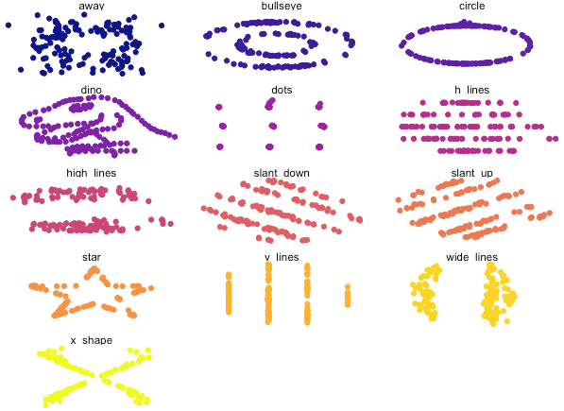
Despite having similar statistical characteristics, the shape of the data was different between datasets (and now you probably understand why this package is called "datasauraus", if you look carefully).
Meta-analysis is no different. Typically, a meta-analyst will construct a forest plot to visualise effect sizes and their variances, which are used to synthesize data into a summary effect size. Here's an example meta-analysis and forest plot and the code to construct it, using a dataset from metafor and a meta-analysis and forest plot function from the meta package.
metafor
meta
library(meta)
library(metafor)
dat <- dat.molloy2014
datcor <- metacor(ri,
ni,
data = dat,
studlab = paste(authors),
method.tau = "REML",
comb.random = TRUE,
comb.fixed = FALSE,
sm = "ZCOR")
meta::forest(datcor, print.I2 = FALSE)
datcor
## OUTPUT WITH SOME INFO OMITTED ##
Number of studies combined: k = 16
COR 95%-CI z p-value
Random effects model 0.1488 [0.0878; 0.2087] 4.75 < 0.0001
Quantifying heterogeneity:
tau^2 = 0.0081 [0.0017; 0.0378]; tau = 0.0901 [0.0412; 0.1944]
I^2 = 60.7% [32.1%; 77.2%]; H = 1.59 [1.21; 2.10]
Test of heterogeneity:
Q d.f. p-value
38.16 15 0.0009
library(meta)
library(metafor)
dat <- dat.molloy2014
datcor <- metacor(ri,
ni,
data = dat,
studlab = paste(authors),
method.tau = "REML",
comb.random = TRUE,
comb.fixed = FALSE,
sm = "ZCOR")
meta::forest(datcor, print.I2 = FALSE)
datcor
## OUTPUT WITH SOME INFO OMITTED ##
Number of studies combined: k = 16
COR 95%-CI z p-value
Random effects model 0.1488 [0.0878; 0.2087] 4.75 < 0.0001
Quantifying heterogeneity:
tau^2 = 0.0081 [0.0017; 0.0378]; tau = 0.0901 [0.0412; 0.1944]
I^2 = 60.7% [32.1%; 77.2%]; H = 1.59 [1.21; 2.10]
Test of heterogeneity:
Q d.f. p-value
38.16 15 0.0009
Looking at the results of the meta-analysis, the random-effects model was statistically significant (p < .0001), with a summary effect size estimate of 0.1488. The test of heterogeneity was also statistically significant (p < .0009).
Now let's look at our forest plot. Of course, this is very subjective, but forest plots can identify studies that are worth closer inspection.
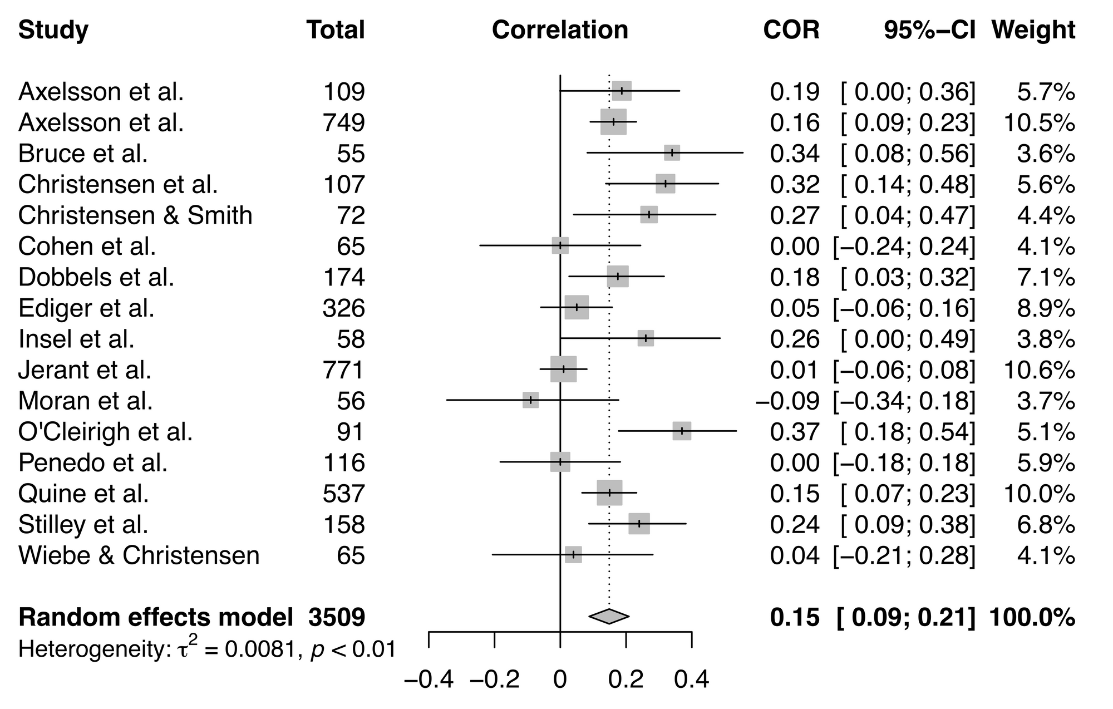
On first glance, there aren't any studies that stand out in this meta-analysis, but it's always worth taking a more in-depth look at possible outliers and influential studies.
One approach for outlier detection is a "leave-one-out" analysis, which assesses the influence of individual studies by performing a series of meta-analyses that leave out one of the studies in the original meta-analysis. The general concept with this analysis is that by removing one study, you can observe how much the results change, thus demonstrating the effect of the inclusion of that particular study on your results.
It's worth noting that none of these tests within a leave-one-out analysis is a definitive test, as you're arbitrarily excluding one study per analysis that would ordinarily meet your inclusion criteria. So if your primary meta-analysis was not statistically significant but one of your leave-one-out meta-analyses were significant, you can't make big claims regarding the significance of your finding. Instead, consider this approach a sensitivity test.
Leave-one-out analysis can also help identify sources of heterogeneity. Perhaps there are two studies that seem to be influential—what is it about those studies that make them influential? Maybe they include participants from the same kind of population? Sometimes these factors don't become clear until you see these studies grouped together via leave-one-out analysis.
It's straightforward to perform a leave-one-out analysis using the metafor R package. The influence()function contains a suite of leave-one-out diagnostic tests, summarised in Viechtbauer & Cheung (2010), that you can run to help identify influential studies.
metafor
influence()
library(metafor)
dat <- dat.molloy2014
dat <- escalc(measure="ZCOR",
ri=ri, ni=ni,
data=dat.molloy2014,
slab=paste(authors, year, sep=", "))
res <- rma(yi, vi, data=dat)
inf <- influence(res)
inf
# OUTPUT #
rstudent dffits cook.d cov.r
Axelsson et al., 2009 0.2918 0.0485 0.0025 1.1331
Axelsson et al., 2011 0.1196 -0.0031 0.0000 1.2595
Bruce et al., 2010 1.2740 0.2595 0.0660 0.9942
Christensen et al., 1999 1.4711 0.3946 0.1439 0.9544
Christensen & Smith, 1995 0.8622 0.1838 0.0339 1.0505
Cohen et al., 2004 -0.9795 -0.2121 0.0455 1.0639
Dobbels et al., 2005 0.2177 0.0296 0.0010 1.1740
Ediger et al., 2007 -0.9774 -0.3120 0.1001 1.1215
Insel et al., 2006 0.7264 0.1392 0.0195 1.0561
Jerant et al., 2011 -1.8667 -0.5861 0.2198 0.8502
Moran et al., 1997 -1.4985 -0.2771 0.0756 1.0073
O'Cleirigh et al., 2007 1.8776 0.4918 0.2148 0.8819
Penedo et al., 2003 -1.1892 -0.2939 0.0859 1.0550
Quine et al., 2012 -0.0020 -0.0423 0.0021 1.2524
Stilley et al., 2004 0.8066 0.2126 0.0459 1.0907
Wiebe & Christensen, 1997 -0.7160 -0.1656 0.0280 1.0853
tau2.del QE.del hat weight
Axelsson et al., 2009 0.0091 37.7109 0.0568 5.6776
Axelsson et al., 2011 0.0100 36.7672 0.1054 10.5396
Bruce et al., 2010 0.0075 35.3930 0.0364 3.6432
Christensen et al., 1999 0.0068 33.5886 0.0562 5.6195
Christensen & Smith, 1995 0.0082 36.5396 0.0441 4.4069
Cohen et al., 2004 0.0084 37.1703 0.0411 4.1094
Dobbels et al., 2005 0.0094 37.6797 0.0714 7.1362
Ediger et al., 2007 0.0084 36.1484 0.0889 8.8886
Insel et al., 2006 0.0083 37.0495 0.0379 3.7886
Jerant et al., 2011 0.0047 25.0661 0.1058 10.5826
Moran et al., 1997 0.0077 35.6617 0.0369 3.6922
O'Cleirigh et al., 2007 0.0059 31.9021 0.0511 5.1150
Penedo et al., 2003 0.0080 36.3291 0.0587 5.8732
Quine et al., 2012 0.0100 37.7339 0.0998 9.9778
Stilley et al., 2004 0.0083 35.8385 0.0684 6.8403
Wiebe & Christensen, 1997 0.0087 37.7017 0.0411 4.1094
dfbs inf
Axelsson et al., 2009 0.0481
Axelsson et al., 2011 -0.0032
Bruce et al., 2010 0.2623
Christensen et al., 1999 0.3994
Christensen & Smith, 1995 0.1837
Cohen et al., 2004 -0.2112
Dobbels et al., 2005 0.0296
Ediger et al., 2007 -0.3128
Insel et al., 2006 0.1387
Jerant et al., 2011 -0.5430
Moran et al., 1997 -0.2791
O'Cleirigh et al., 2007 0.5059
Penedo et al., 2003 -0.2941
Quine et al., 2012 -0.0434
Stilley et al., 2004 0.2125
Wiebe & Christensen, 1997 -0.1642
library(metafor)
dat <- dat.molloy2014
dat <- escalc(measure="ZCOR",
ri=ri, ni=ni,
data=dat.molloy2014,
slab=paste(authors, year, sep=", "))
res <- rma(yi, vi, data=dat)
inf <- influence(res)
inf
# OUTPUT #
rstudent dffits cook.d cov.r
Axelsson et al., 2009 0.2918 0.0485 0.0025 1.1331
Axelsson et al., 2011 0.1196 -0.0031 0.0000 1.2595
Bruce et al., 2010 1.2740 0.2595 0.0660 0.9942
Christensen et al., 1999 1.4711 0.3946 0.1439 0.9544
Christensen & Smith, 1995 0.8622 0.1838 0.0339 1.0505
Cohen et al., 2004 -0.9795 -0.2121 0.0455 1.0639
Dobbels et al., 2005 0.2177 0.0296 0.0010 1.1740
Ediger et al., 2007 -0.9774 -0.3120 0.1001 1.1215
Insel et al., 2006 0.7264 0.1392 0.0195 1.0561
Jerant et al., 2011 -1.8667 -0.5861 0.2198 0.8502
Moran et al., 1997 -1.4985 -0.2771 0.0756 1.0073
O'Cleirigh et al., 2007 1.8776 0.4918 0.2148 0.8819
Penedo et al., 2003 -1.1892 -0.2939 0.0859 1.0550
Quine et al., 2012 -0.0020 -0.0423 0.0021 1.2524
Stilley et al., 2004 0.8066 0.2126 0.0459 1.0907
Wiebe & Christensen, 1997 -0.7160 -0.1656 0.0280 1.0853
tau2.del QE.del hat weight
Axelsson et al., 2009 0.0091 37.7109 0.0568 5.6776
Axelsson et al., 2011 0.0100 36.7672 0.1054 10.5396
Bruce et al., 2010 0.0075 35.3930 0.0364 3.6432
Christensen et al., 1999 0.0068 33.5886 0.0562 5.6195
Christensen & Smith, 1995 0.0082 36.5396 0.0441 4.4069
Cohen et al., 2004 0.0084 37.1703 0.0411 4.1094
Dobbels et al., 2005 0.0094 37.6797 0.0714 7.1362
Ediger et al., 2007 0.0084 36.1484 0.0889 8.8886
Insel et al., 2006 0.0083 37.0495 0.0379 3.7886
Jerant et al., 2011 0.0047 25.0661 0.1058 10.5826
Moran et al., 1997 0.0077 35.6617 0.0369 3.6922
O'Cleirigh et al., 2007 0.0059 31.9021 0.0511 5.1150
Penedo et al., 2003 0.0080 36.3291 0.0587 5.8732
Quine et al., 2012 0.0100 37.7339 0.0998 9.9778
Stilley et al., 2004 0.0083 35.8385 0.0684 6.8403
Wiebe & Christensen, 1997 0.0087 37.7017 0.0411 4.1094
dfbs inf
Axelsson et al., 2009 0.0481
Axelsson et al., 2011 -0.0032
Bruce et al., 2010 0.2623
Christensen et al., 1999 0.3994
Christensen & Smith, 1995 0.1837
Cohen et al., 2004 -0.2112
Dobbels et al., 2005 0.0296
Ediger et al., 2007 -0.3128
Insel et al., 2006 0.1387
Jerant et al., 2011 -0.5430
Moran et al., 1997 -0.2791
O'Cleirigh et al., 2007 0.5059
Penedo et al., 2003 -0.2941
Quine et al., 2012 -0.0434
Stilley et al., 2004 0.2125
Wiebe & Christensen, 1997 -0.1642
This analysis also provides a classification for what's considered influential. Look for an asterisk in the last column of the output, called 'inf' (this particular analysis had no influential studies, so there are no asterisks here). See the metafor documentation for what's considered influential, but here's an important point from this document worth emphasising:
metafor
Note that the chosen cut-offs are (somewhat) arbitrary. Substantively informed judgment should always be used when examining the influence of each study on the results.
Note that the chosen cut-offs are (somewhat) arbitrary. Substantively informed judgment should always be used when examining the influence of each study on the results.
You can also make the same plot (with slightly different names for the influence tests) using the dmetar package:
dmetar
library(devtolls)
devtools::install_github("MathiasHarrer/dmetar")
library(dmetar)
inf.analysis <- InfluenceAnalysis(x = datcor, random = TRUE)
plot(inf.analysis, "influence")
library(devtolls)
devtools::install_github("MathiasHarrer/dmetar")
library(dmetar)
inf.analysis <- InfluenceAnalysis(x = datcor, random = TRUE)
plot(inf.analysis, "influence")
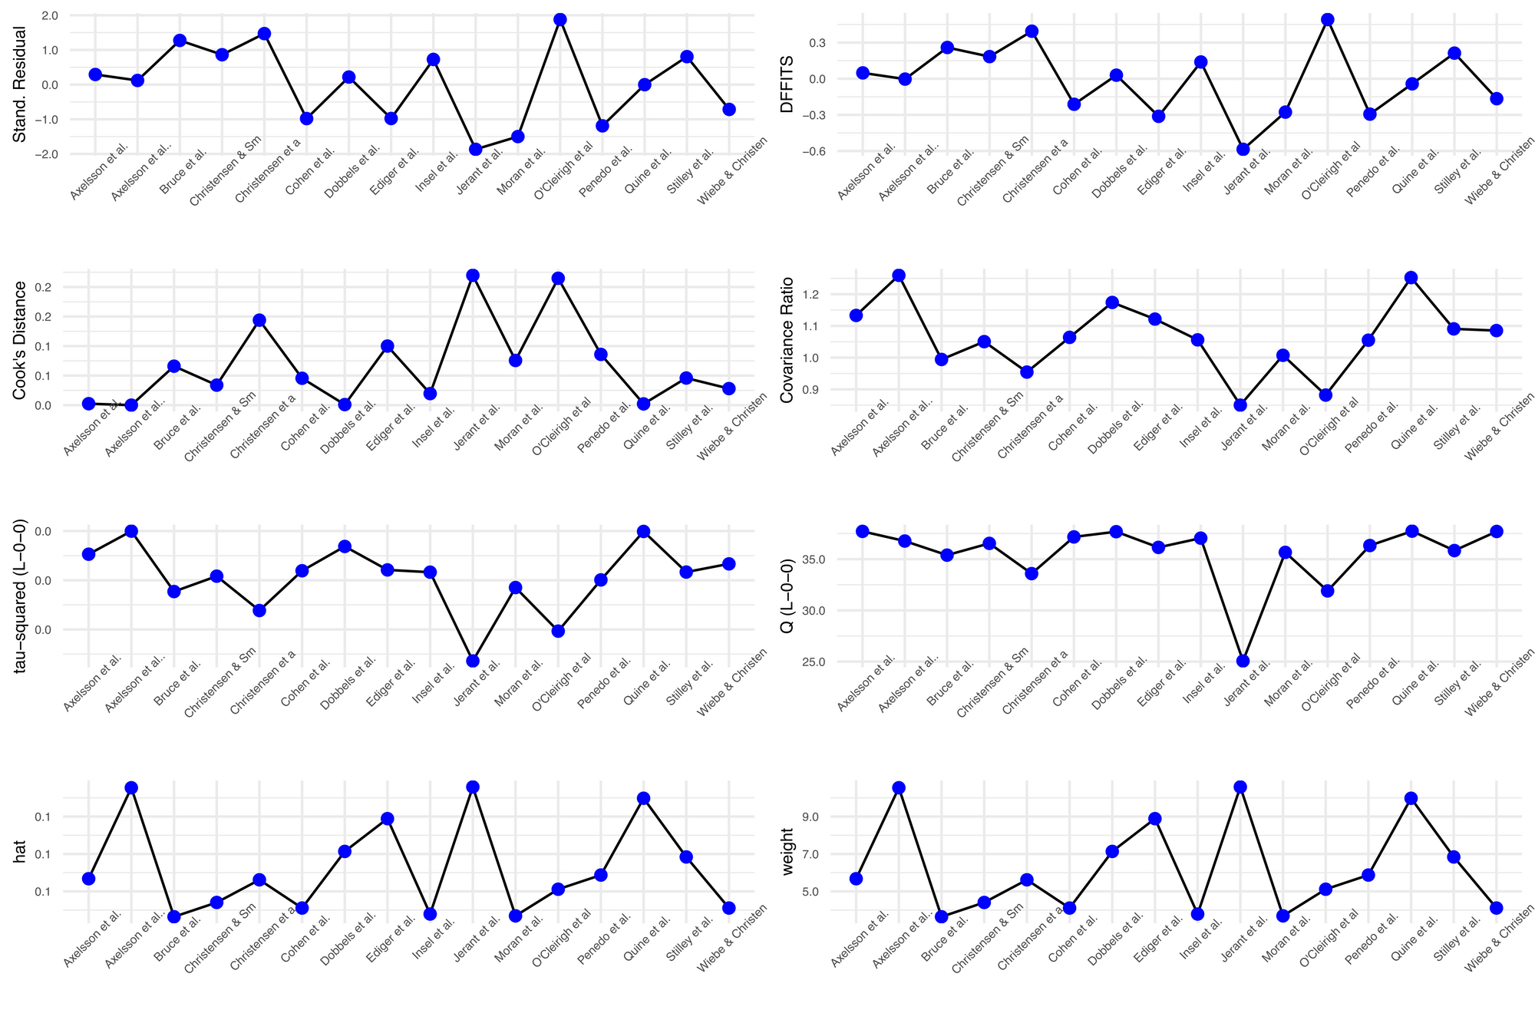
If you want a nice visualisation for your leave-one-out analysis, you can pair the 'meta' and 'dmetar' packages:
library(dmetar)
library(meta)
library(metafor)
dat <- dat.molloy2014
datcor <- metacor(ri,
ni,
data = dat,
studlab = paste(authors),
method.tau = "REML",
comb.random = TRUE,
comb.fixed = FALSE,
sm = "ZCOR")
inf.analysis <- InfluenceAnalysis(x = datcor,
random = TRUE)
plot(inf.analysis, "es")
library(dmetar)
library(meta)
library(metafor)
dat <- dat.molloy2014
datcor <- metacor(ri,
ni,
data = dat,
studlab = paste(authors),
method.tau = "REML",
comb.random = TRUE,
comb.fixed = FALSE,
sm = "ZCOR")
inf.analysis <- InfluenceAnalysis(x = datcor,
random = TRUE)
plot(inf.analysis, "es")
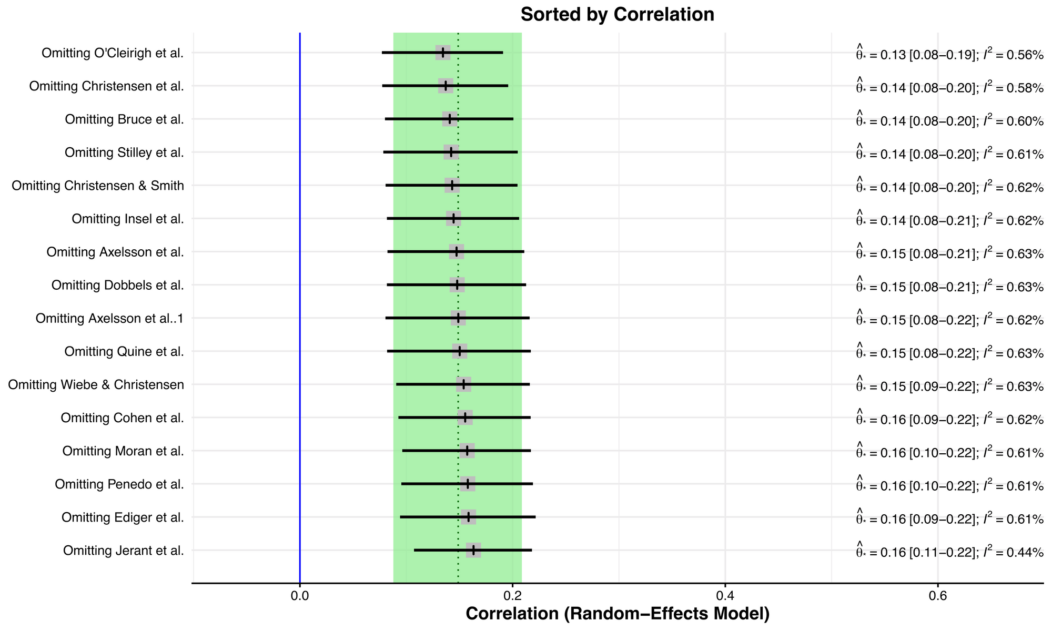
This plot is like a forest plot, but instead of visualising the effect size and variance for each study in each row, it visualises the summary effect sizes for meta-analyses without the study named in each row. The original summary effect size (including all studies) is shown as a dotted vertical line, and the 95% confidence interval of the original meta-analysis is shown by the green bounds. In this example, there isn't a big shift between the smallest correlation at the top and the largest correlation at the bottom.
Outliers just based on effect size are easier to eyeball from a forest plot, however, an outlier of heterogeneity is a little tricker to identify.
To better understand studies that are influential in terms of heterogeneity, you can also order the plot via I2, which is one measure of heterogeneity. While a single study effect size may not have a large influence on the summary effect size, it could have an impact on heterogeneity.
plot(inf.analysis, "I2")
plot(inf.analysis, "I2")
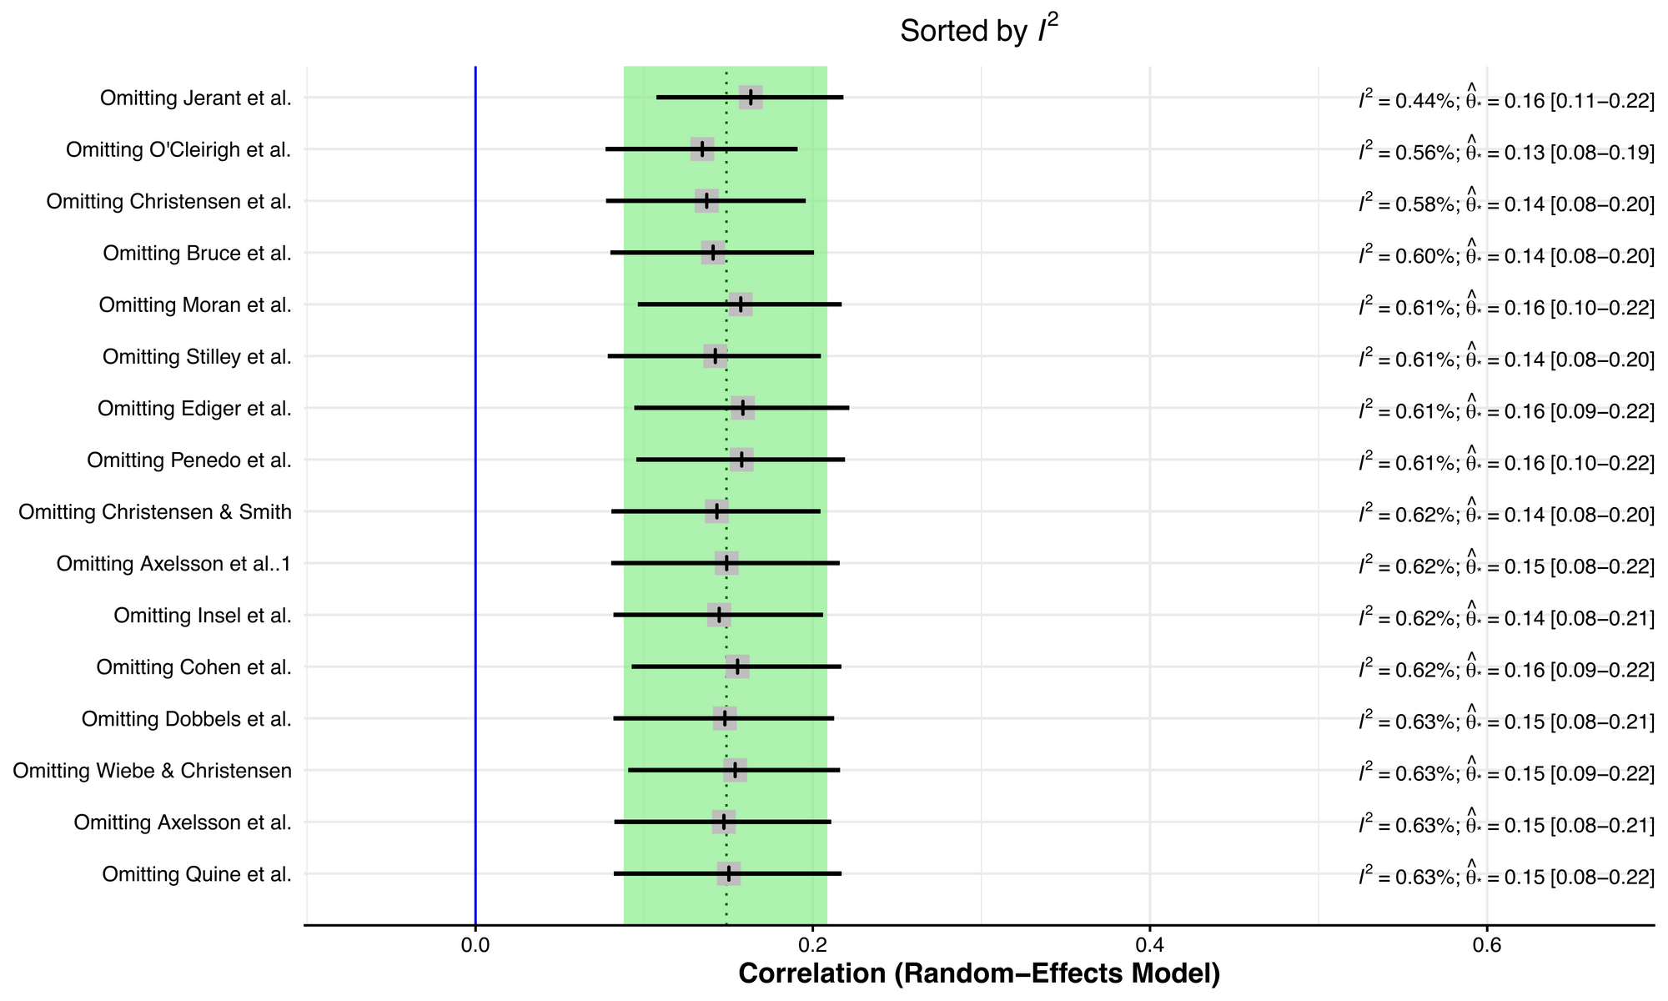
Removing the Jerant et al study seems to have an appreciable effect on reducing study heterogeneity. To more closely explore this, we can construct a Baujat plot, which shows the overall heterogeneity contribution for each study against the influence on the pooled result for each study.
plot(inf.analysis, "baujat")
plot(inf.analysis, "baujat")
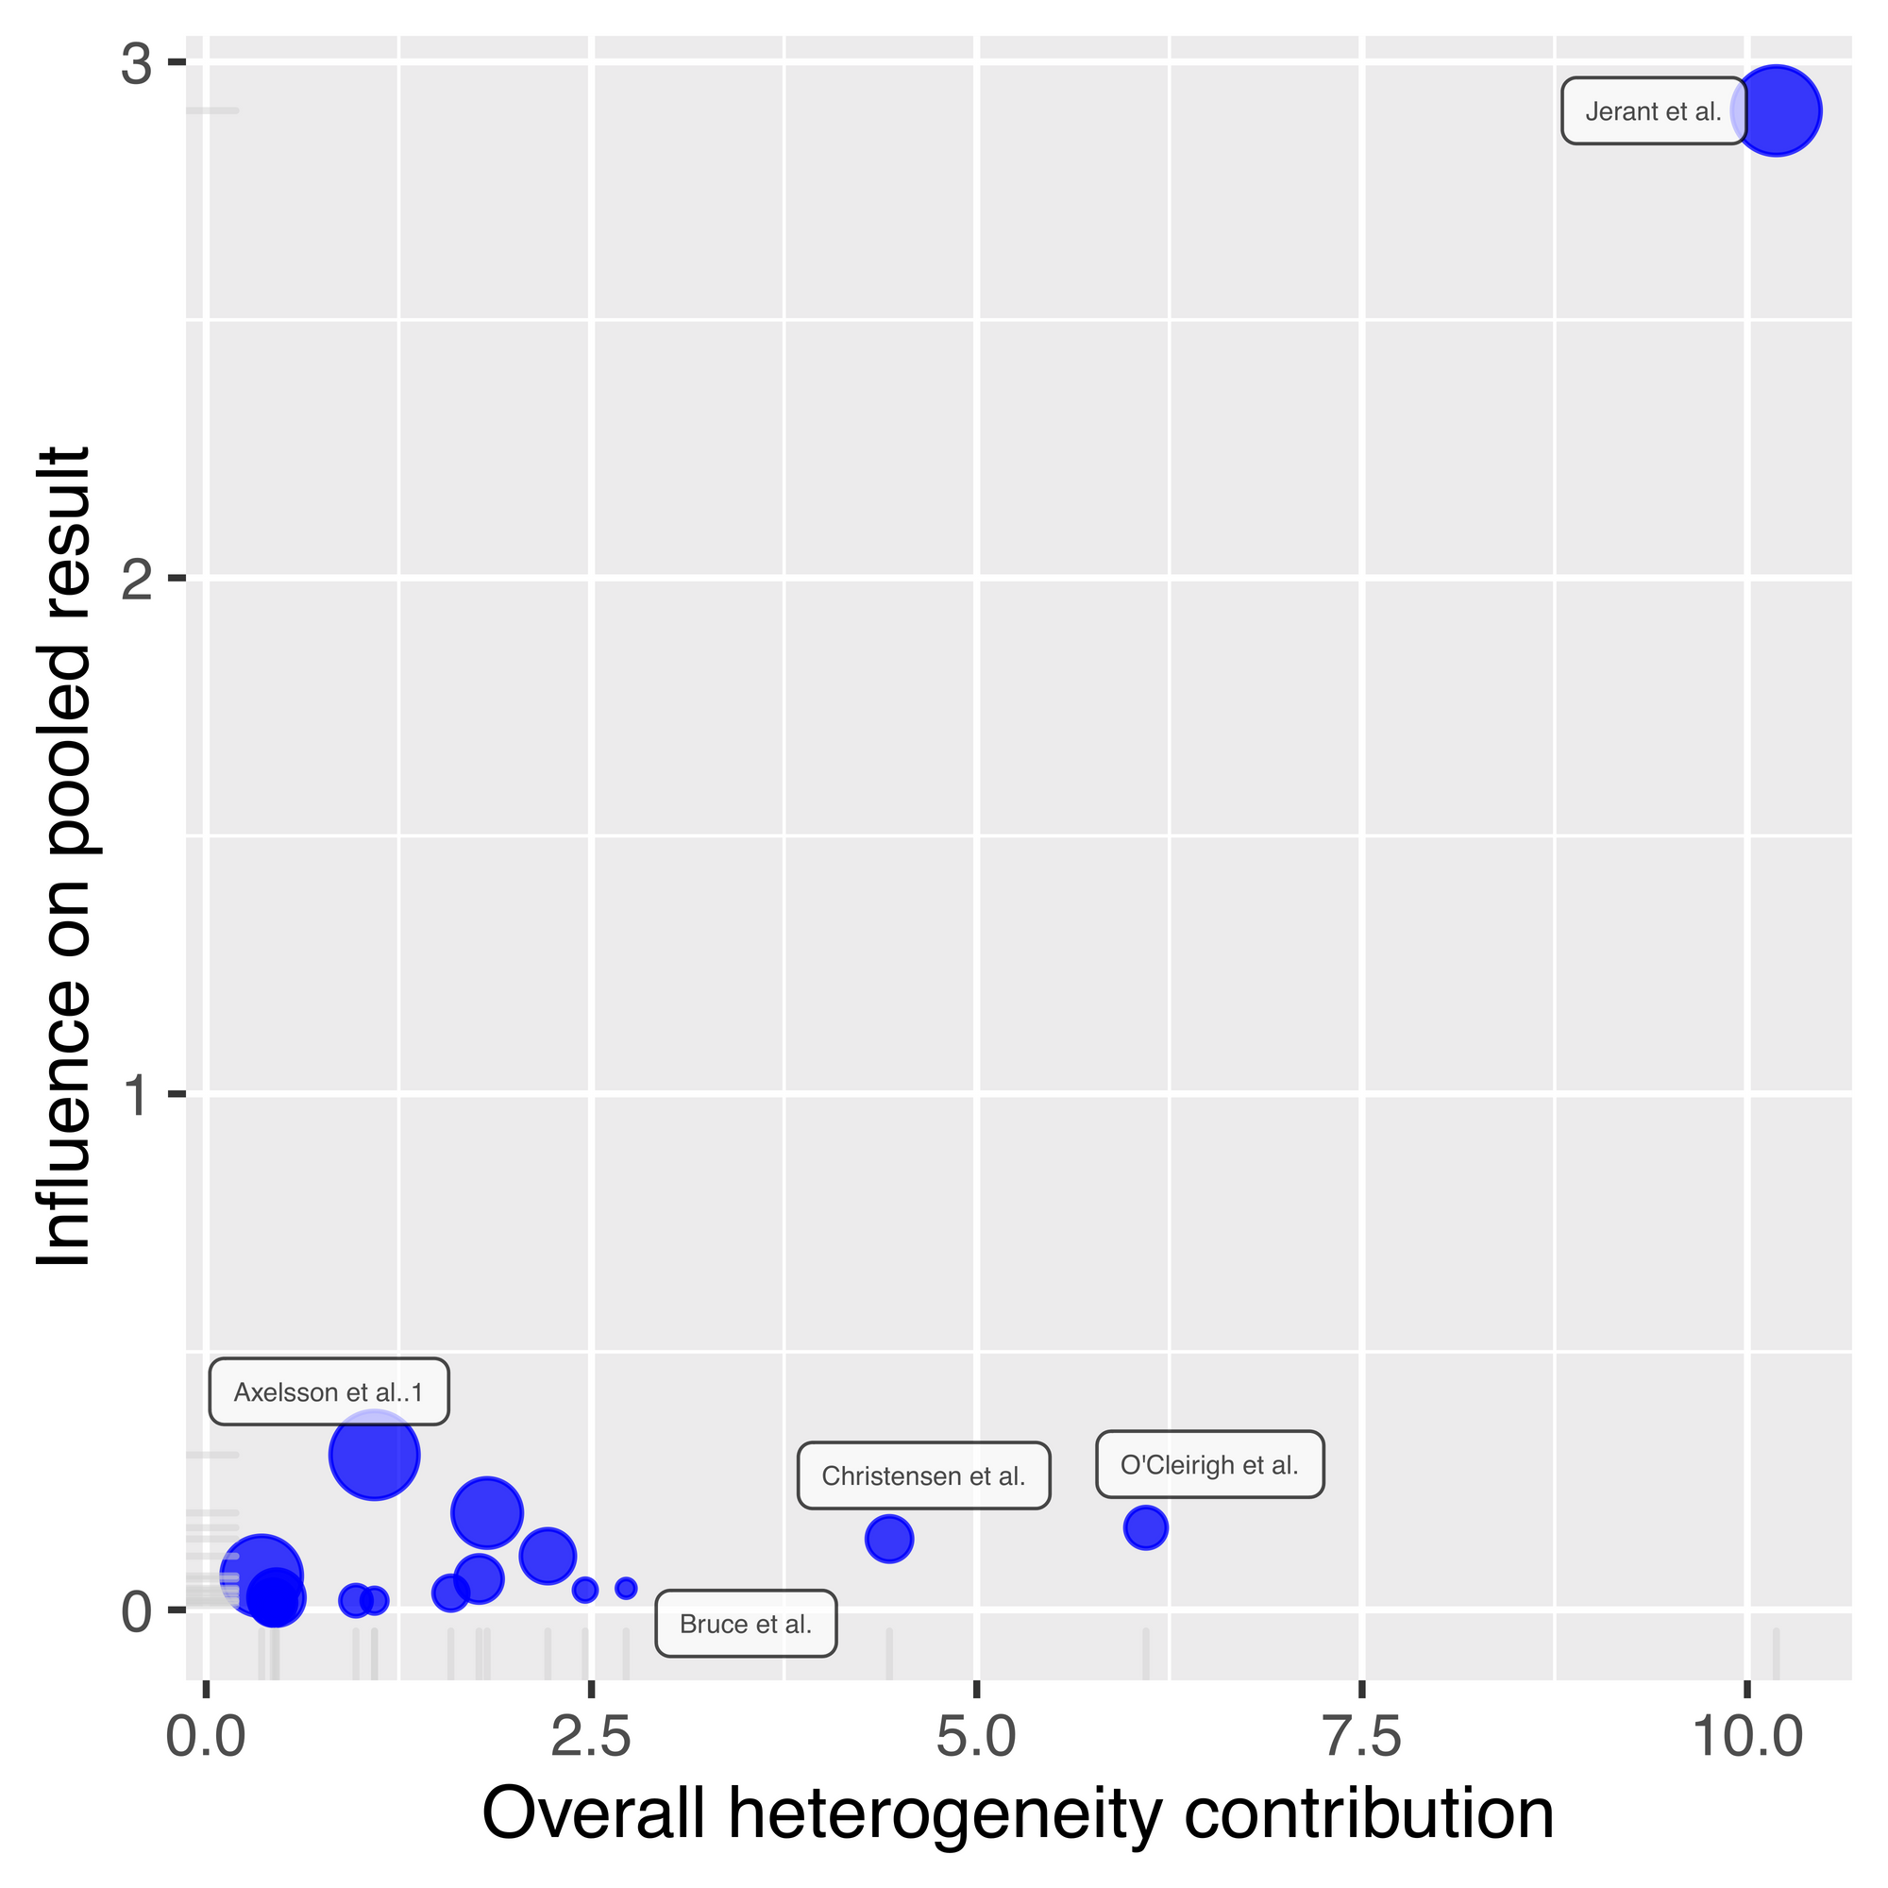
Jerant et al is really sticking out now, as it has almost three times more influence on the pooled result compared to all other studies, and a comparatively high overall heterogeneity contribution. If we look back at our leave-one-out plot ordered by correlation, removing Jerant et al leads to the largest effect size, but it's not the largest by much. This indicates that this Jerant et al is pulling down the overall summary effect size estimate, but not by a large amount.

What do you do if your analysis identifies potential outlier studies?
I don't think that outliers shouldn't be removed from your primary analysis, unless they're implausible.
What do I mean by implausible?
To give a recent example, a man in the UK was put into the priority list for a COVID vaccine due to morbid obesity. Thinking that this may have been a mistake, as he considered his weight to be relatively normal, he followed this up to discover that the local authorities had him registered with a BMI of 28,000, because his height of 6ft 2ins was noted as 6.2cm instead. As BMI of 40 and over is considered 'morbidly obese', a BMI value of 28,000 is obviously implausible.
Leave-one-out analyses are better framed as robustness checks and as a way to identify sources of study heterogeneity that you may have missed otherwise. You've set your inclusion/exclusion criteria for your meta-analysis for a reason, so if a study fulfills criteria, then it should be included.
Outlier analyses are also a good check to make sure that you have entered numbers correctly. A common reason for mistakes in meta-analysis is that standard error and standard deviation get mixed up. Of course, this should be carefully checked for all studies, but outlier analysis is a good backstop, just in case.
It's worthwhile reporting your leave-one-out analysis, regardless of whether you discover outliers. If your result hangs on the inclusion of a single study, then your findings aren't terribly robust and this should be made clear in the discussion of your results.

How to perform a Bayesian meta-analysis in R
Fuente: https://www.dsquintana.blog/how-to-perform-a-bayesian-meta-analysis-in-r/
Meta-analyses conventionally adopt a frequentist approach, in which a p-value is used to make a binary decision regarding the presence of an effect. While correctly used p-values can be useful, using a Bayesian framework can provide a number of benefits for the meta-analyst. However, Bayesian meta-analysis is uncommon, probably due to a historical lack of accessible software options for performing these tests. So in this post I'm going to outline the benefits of Bayesian meta-analysis and a step-by-step guide (with code) on to perform one using the relatively new "RoBMA" R package.
I've previously outlined the benefits of using a Bayesian framework for hypothesis testing in a 2018 paper, but there are two benefits that are particularly interesting for meta-analysis, which are worth covering before diving into the code.
First, Bayes factors are an intuitive metric for describing and understanding the relative evidence for two models, typically an alternative model vs. a null model. So using this approach, one could say that there's 12 times more evidence for an alternative model compared to a null model, for instance. Of course, frequentist meta-analysis can be reported with effect sizes, but interpreting effect sizes can be difficult, as Cohen's benchmarks of small/medium/large effects are not universal across research fields.
Second, non-significant p-values carry very little information, as these values can either suggest the absence of evidence or evidence of absence, regardless of the size of your p-value. As alluded to above, with Bayes factors you can also assess the relative evidence for a null model compared to an alternative model (unlike null hypothesis testing in which you can only reject a null hypothesis). Along with estimating the relative evidence for meta-analytic models, Bayes factors can also be used to estimate the relative evidence for publication bias. Frequentist approaches for publication suffer this same limitation, in that a non-significant test for publication bias can either suggest the absence of evidence or evidence of absence.
To illustrate the differences between a frequentist and Bayesian meta-analysis, I'm going to use an example that I've used for a previous tutorial paper for a frequentist meta-analysis. This dataset contains 17 studies that report the correlation between medication adherence and a measure of conscientiousness.
Let's run a frequentist analysis and construct a forest plot to visualise the result using the following script:
library(metafor) #load the metafor package
dat <- dat.molloy2014 # Extract the dataset
dat <- escalc(measure="ZCOR",
ri=ri, ni=ni,
data=dat.molloy2014,
slab=paste(authors, year, sep=", "))
res <- rma(yi, vi, data=dat) # Perform meta-analysis
res # print results
library(metafor) #load the metafor package
dat <- dat.molloy2014 # Extract the dataset
dat <- escalc(measure="ZCOR",
ri=ri, ni=ni,
data=dat.molloy2014,
slab=paste(authors, year, sep=", "))
res <- rma(yi, vi, data=dat) # Perform meta-analysis
res # print results
Here are the results, followed by a forest plot:
Random-Effects Model (k = 16; tau^2 estimator: REML)
tau^2 (estimated amount of total heterogeneity): 0.0081 (SE = 0.0055)
tau (square root of estimated tau^2 value): 0.0901
I^2 (total heterogeneity / total variability): 61.73%
H^2 (total variability / sampling variability): 2.61
Test for Heterogeneity:
Q(df = 15) = 38.1595, p-val = 0.0009
Model Results:
estimate se zval pval ci.lb ci.ub
0.1499 0.0316 4.7501 <.0001 0.0881 0.2118 ***
---
Signif. codes: 0 ‘***’ 0.001 ‘**’ 0.01 ‘*’ 0.05 ‘.’ 0.1 ‘ ’ 1
Random-Effects Model (k = 16; tau^2 estimator: REML)
tau^2 (estimated amount of total heterogeneity): 0.0081 (SE = 0.0055)
tau (square root of estimated tau^2 value): 0.0901
I^2 (total heterogeneity / total variability): 61.73%
H^2 (total variability / sampling variability): 2.61
Test for Heterogeneity:
Q(df = 15) = 38.1595, p-val = 0.0009
Model Results:
estimate se zval pval ci.lb ci.ub
0.1499 0.0316 4.7501 <.0001 0.0881 0.2118 ***
---
Signif. codes: 0 ‘***’ 0.001 ‘**’ 0.01 ‘*’ 0.05 ‘.’ 0.1 ‘ ’ 1
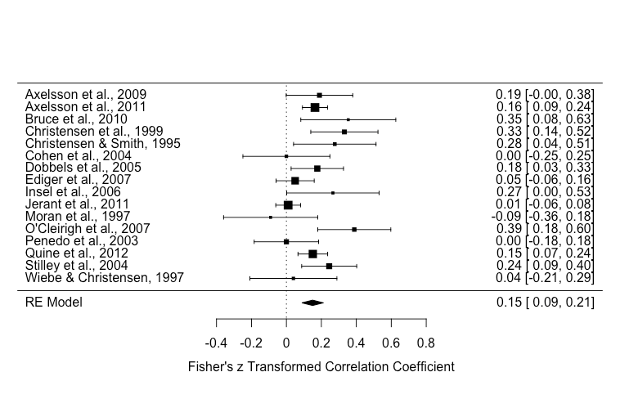
Of note, there was significant heterogeneity [Q(df = 15) = 38.1595, p-value = 0.0009] and the effect size estimate was 0.15 (p < .001).
Conventionally, a meta-analyst would construct a funnel plot and perform Egger's regression test to assess publication bias via funnel plot asymmetry. But as I've outlined before, funnel plot asymmetry can only assess small study bias which can include publication bias, but also other factors (e.g., study quality).
funnel(res)
regtest(res)
# regtest results #
Regression Test for Funnel Plot Asymmetry
Model: mixed-effects meta-regression model
Predictor: standard error
Test for Funnel Plot Asymmetry: z = 1.0216, p = 0.3070
Limit Estimate (as sei -> 0): b = 0.0790 (CI: -0.0686, 0.2266)
funnel(res)
regtest(res)
# regtest results #
Regression Test for Funnel Plot Asymmetry
Model: mixed-effects meta-regression model
Predictor: standard error
Test for Funnel Plot Asymmetry: z = 1.0216, p = 0.3070
Limit Estimate (as sei -> 0): b = 0.0790 (CI: -0.0686, 0.2266)
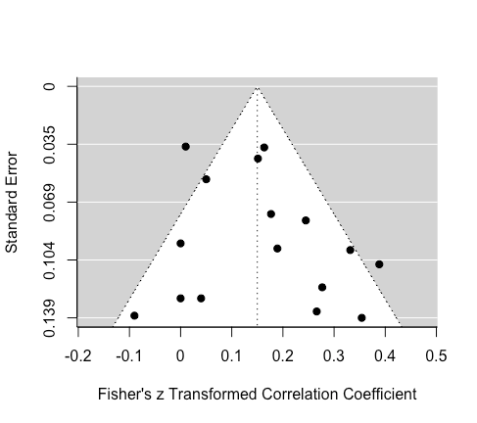
Eyeballing the funnel plot suggests that the distribution of effects is fairly symmetrical. Egger's regression test was non-significant, which suggest either that there is either no asymmetry or the data were not sensitive enough.
Next, let's use an approach that that has been designed to specifically assess publication bias: weight-function models. In short, weight-function models provide a greater weight to studies that were less likely to have been published, based on their associated p value, for the estimation of a summary effect size. For example, it is a fair assumption that a study with a p value of 0.001 is more likely to be published than a study with a p value of 0.45. Other methods for publication bias detection and correction have been proposed, but weight-function models seem to perform the best across a range of situations (e.g., high heterogeneity).
It's worth emphasizing two limitations with selection models: 1) These models assume that the chosen selection model is an good approximation for the underlying selection process (i.e., that the chances of publication depend on the p value). But despite this limitation, weight-function models at least make the selection process is explicit (whereas this the selection process is implicit in other methods, which means they can't be evaluated). 2) Selection-models (like other publication bias methods) are a type of sensitivity analysis, which means that the publication bias model is an estimate that isn't based on real numbers, but a set of assumptions for the how the chances of publication depends on the p value.
There are various approaches for selection models (e.g., a beta model, a power model), but here we will use the Vevea and Hedges (1995) step function approach, which is implemented in the weightr package:
weightr
library(weightr)
weightfunct(dat$yi, dat$vi)
Unadjusted Model (k = 16):
tau^2 (estimated amount of total heterogeneity): 0.0070 (SE = 0.0051)
tau (square root of estimated tau^2 value): 0.0834
Test for Heterogeneity:
Q(df = 15) = 38.1595, p-val = 0.001436053
Model Results:
estimate std.error z-stat p-val ci.lb ci.ub
Intercept 0.1486 0.03073 4.835 1.3288e-06 0.08837 0.2088
Adjusted Model (k = 16):
tau^2 (estimated amount of total heterogeneity): 0.0056 (SE = 0.0045)
tau (square root of estimated tau^2 value): 0.0750
Test for Heterogeneity:
Q(df = 15) = 38.1595, p-val = 0.001436053
Model Results:
estimate std.error z-stat p-val ci.lb ci.ub
Intercept 0.09153 0.04464 2.050 0.040341 0.00403 0.1790
0.025 < p < 1 0.24121 0.20122 1.199 0.230626 -0.15317 0.6356
Likelihood Ratio Test:
X^2(df = 1) = 2.98493, p-val = 0.084043
library(weightr)
weightfunct(dat$yi, dat$vi)
Unadjusted Model (k = 16):
tau^2 (estimated amount of total heterogeneity): 0.0070 (SE = 0.0051)
tau (square root of estimated tau^2 value): 0.0834
Test for Heterogeneity:
Q(df = 15) = 38.1595, p-val = 0.001436053
Model Results:
estimate std.error z-stat p-val ci.lb ci.ub
Intercept 0.1486 0.03073 4.835 1.3288e-06 0.08837 0.2088
Adjusted Model (k = 16):
tau^2 (estimated amount of total heterogeneity): 0.0056 (SE = 0.0045)
tau (square root of estimated tau^2 value): 0.0750
Test for Heterogeneity:
Q(df = 15) = 38.1595, p-val = 0.001436053
Model Results:
estimate std.error z-stat p-val ci.lb ci.ub
Intercept 0.09153 0.04464 2.050 0.040341 0.00403 0.1790
0.025 < p < 1 0.24121 0.20122 1.199 0.230626 -0.15317 0.6356
Likelihood Ratio Test:
X^2(df = 1) = 2.98493, p-val = 0.084043
This output might be new for many people reading, so I'm going to walk through it.
The "model results" section displays the conventional results, in terms of heterogeneity and effect size estimates. Note that the results are not exactly the same as our first analysis above, this is because the weightr package converts correlations to Cohen's d effect sizes for the analysis, and then transforms these results back to correlations.
weightr
The "adjusted model" section includes results accounting for publication bias (note the results in the "intercept" row). The summary effect estimate has shrunk from 0.15 to 0.09, and it is now very close to the threshold of statistical significance. (p = 0.04). A formal comparison of these two models, which tests for publication bias, was statistically significant using a threshold of p = 0.1, which has been recommended by Renkewitz & Keiner, along with Begg & Mazumdar.
This shifted threshold highlights the arbitrary nature of p-value thresholds. Strictly using the conventional significance threshold of p = 0.05, one would conclude that there was no publication bias. However, using a significance threshold of p = 0.1, one conclude that there's indeed publication bias.
As mentioned above, but worth repeating, Bayes factors are values that represent the relative evidence for two competing models, without requiring a strict cutoff. This means that we can do away with the need for making a binary decision when it comes to evaluating the presence of publication bias.
So let's now jump in and perform Bayesian hypothesis tests using the RoBMA R package. This package generates three families of models, across 12 models, then averages their performance. These models vary on whether they're fixed or random effects models (i.e., assuming heterogeneity), a null or alternative hypothesis models, or whether models include the presence of publication bias or not. In terms of publication bias models, separate models also use a two-step approach (significant or non-significant) or a three-step approach (significant, marginally significant, or non-significant). For more information, see Maier and colleagues.
RoBMA
Before running this analysis, just keep in mind that this can take some time, depending on the speed of your computer. It took my five-year-old MacBook Pro just over five minutes to complete these analyses, for reference.
fit <- RoBMA(r = dat$ri,
n = dat$ni,
study_names = dat$authors,
seed = 2333)
summary(fit)
## OUTPUT ###
Call:
RoBMA(r = dat$ri, n = dat$ni, study_names = dat$authors, seed = 2333)
Robust Bayesian Meta-Analysis
Models Prior prob. Post. prob. Incl. BF
Effect 6/12 0.500 0.992 119.310
Heterogeneity 6/12 0.500 0.963 25.726
Pub. bias 8/12 0.500 0.544 1.194
Model-averaged estimates
Mean Median 0.025 0.975
mu 0.129 0.129 0.057 0.202
tau 0.163 0.158 0.000 0.320
omega[0,0.05] 1.000 1.000 1.000 1.000
omega[0.05,0.1] 0.814 0.956 0.252 1.000
omega[0.1,1] 0.718 0.848 0.153 1.000
(Tau is on Cohen's d scale.)
(Estimated omegas correspond to two-sided p-values)
fit <- RoBMA(r = dat$ri,
n = dat$ni,
study_names = dat$authors,
seed = 2333)
summary(fit)
## OUTPUT ###
Call:
RoBMA(r = dat$ri, n = dat$ni, study_names = dat$authors, seed = 2333)
Robust Bayesian Meta-Analysis
Models Prior prob. Post. prob. Incl. BF
Effect 6/12 0.500 0.992 119.310
Heterogeneity 6/12 0.500 0.963 25.726
Pub. bias 8/12 0.500 0.544 1.194
Model-averaged estimates
Mean Median 0.025 0.975
mu 0.129 0.129 0.057 0.202
tau 0.163 0.158 0.000 0.320
omega[0,0.05] 1.000 1.000 1.000 1.000
omega[0.05,0.1] 0.814 0.956 0.252 1.000
omega[0.1,1] 0.718 0.848 0.153 1.000
(Tau is on Cohen's d scale.)
(Estimated omegas correspond to two-sided p-values)
Let's go through these results, first addressing the "Robust Bayesian meta-analysis" section. The "Effect" row includes a Bayes Factor ("Incl. BF") of 119, which indicates that there is 119 times more evidence for an effect model relative to a null model. The "Heterogeneity" row indicates that there is 26 times more evidence for a heterogeneity model than a model without heterogeneity. Finally, the "Pub. bias" row indicates that there's 1.2 times more evidence for a publication model than a model without publication bias, which is very small evidence.
The "Model-averaged estimates" section contains an estimate of the summary effect size (mu), which was 0.13. Keep in mind that this is the values that is averaged across all models, including publication bias models, so this is a publication bias adjusted value.
Let's compare this model-averaged estimate against the a model that parallels the conventional frequentist approach: A model that assumes an effect with heterogeneity and no publication bias (i.e., a random-effects meta-analysis). This is model #10 in our analysis, and information for this model can be found by entering this command: summary(fit, type = "individual"). This command will list information from all 12 models (output not shown here for the sake of space). For model #10, the mean estimate was 0.15, which mirrors our conventional frequentist analysis above.
summary(fit, type = "individual")
The "Model-averaged estimates" section also provides interesting information regarding the relative probability of publication of results of significant (the omega[0,0.05] row), marginally significant (the omega[0.05,0.1] row), and non-significant (the omega[0.1,1] row) results. This analysis suggested there was 100% probability that significant results (p < 0.05) were published, which is a consequence of how the model was set up, a 81.4% probability that marginally signficant results (.05 < p < .10) were published (relative to significant studies), and 71.8% chance that non-significant results (p > 0.1) were published (relative to significant studies).
omega[0,0.05]
omega[0.05,0.1]
omega[0.1,1]
We can also plot these results using this command: plot(fit, parameter = "omega")
plot(fit, parameter = "omega")
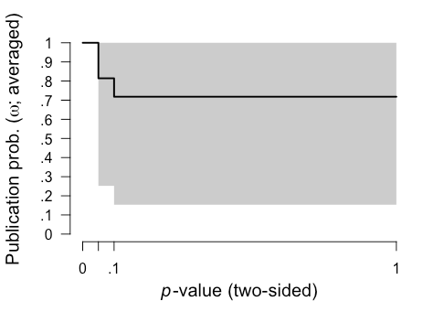
It's also important to check the diagnostics of these 12 models to identify any issues. Rhat convergence and the effect sampling size (ESS) provide a summary of Markov chain Monte Carlo (MCMC) convergence for the appropriateness of drawing inferences. It's recommended that Rhat convergence values should be under 1.05 and that the effect sampling size (ESS) is sufficiently large. There's no clear rule-of-thumb for what constitutes a "large" ESS, but even an ESS of a few hundred is fine if you're only interested in the posterior means. We can easily generate a summary including diagnostics with this code:
summary(fit, type = "models", diagnostics = TRUE)
# OUTPUT WITH SOME INFO OMITTED FOR SPACE #
Models diagnostics overview
Prior mu Prior tau
1 Spike(0) Spike(0)
2 Spike(0) Spike(0)
3 Spike(0) Spike(0)
4 Spike(0) InvGamma(1, 0.15)[0, Inf]
5 Spike(0) InvGamma(1, 0.15)[0, Inf]
6 Spike(0) InvGamma(1, 0.15)[0, Inf]
7 Normal(0, 1)[-Inf, Inf] Spike(0)
8 Normal(0, 1)[-Inf, Inf] Spike(0)
9 Normal(0, 1)[-Inf, Inf] Spike(0)
10 Normal(0, 1)[-Inf, Inf] InvGamma(1, 0.15)[0, Inf]
11 Normal(0, 1)[-Inf, Inf] InvGamma(1, 0.15)[0, Inf]
12 Normal(0, 1)[-Inf, Inf] InvGamma(1, 0.15)[0, Inf]
Prior omega max(MCMC error) min(ESS) max(Rhat)
1 Spike(1) NA NA NA
2 Two-sided((0.05), (1, 1)) 0.000 7776 1.000
3 Two-sided((0.1, 0.05), (1, 1, 1)) 0.002 8239 1.001
4 Spike(1) 0.001 18675 1.000
5 Two-sided((0.05), (1, 1)) 0.003 7924 1.001
6 Two-sided((0.1, 0.05), (1, 1, 1)) 0.002 7786 1.000
7 Spike(1) 0.000 30050 1.000
8 Two-sided((0.05), (1, 1)) 0.002 9407 1.001
9 Two-sided((0.1, 0.05), (1, 1, 1)) 0.002 8700 1.000
10 Spike(1) 0.001 12525 1.000
11 Two-sided((0.05), (1, 1)) 0.002 9540 1.000
12 Two-sided((0.1, 0.05), (1, 1, 1)) 0.002 8049 1.001
summary(fit, type = "models", diagnostics = TRUE)
# OUTPUT WITH SOME INFO OMITTED FOR SPACE #
Models diagnostics overview
Prior mu Prior tau
1 Spike(0) Spike(0)
2 Spike(0) Spike(0)
3 Spike(0) Spike(0)
4 Spike(0) InvGamma(1, 0.15)[0, Inf]
5 Spike(0) InvGamma(1, 0.15)[0, Inf]
6 Spike(0) InvGamma(1, 0.15)[0, Inf]
7 Normal(0, 1)[-Inf, Inf] Spike(0)
8 Normal(0, 1)[-Inf, Inf] Spike(0)
9 Normal(0, 1)[-Inf, Inf] Spike(0)
10 Normal(0, 1)[-Inf, Inf] InvGamma(1, 0.15)[0, Inf]
11 Normal(0, 1)[-Inf, Inf] InvGamma(1, 0.15)[0, Inf]
12 Normal(0, 1)[-Inf, Inf] InvGamma(1, 0.15)[0, Inf]
Prior omega max(MCMC error) min(ESS) max(Rhat)
1 Spike(1) NA NA NA
2 Two-sided((0.05), (1, 1)) 0.000 7776 1.000
3 Two-sided((0.1, 0.05), (1, 1, 1)) 0.002 8239 1.001
4 Spike(1) 0.001 18675 1.000
5 Two-sided((0.05), (1, 1)) 0.003 7924 1.001
6 Two-sided((0.1, 0.05), (1, 1, 1)) 0.002 7786 1.000
7 Spike(1) 0.000 30050 1.000
8 Two-sided((0.05), (1, 1)) 0.002 9407 1.001
9 Two-sided((0.1, 0.05), (1, 1, 1)) 0.002 8700 1.000
10 Spike(1) 0.001 12525 1.000
11 Two-sided((0.05), (1, 1)) 0.002 9540 1.000
12 Two-sided((0.1, 0.05), (1, 1, 1)) 0.002 8049 1.001
For all of our models, the largest Rhat convergence values [the max(Rhat) column] column was 1.001 and the smallest ESS [min(ESS) column] was 7776, so we can be confident of good MCMC convergence, and be on our way. If Rhat convergence values are over 1.05 or ESS values are below a few hundred, then you can try re-running your analysis with an increased number of sampling iterations and burnin. Of course, this will take longer to compute.
Keep in mind that these analyses are using a series of default prior distributions, which are designed to represent typical effects in the psychological sciences. For details on adjusting the your prior distributions, see Maier and colleagues.
In summary, our analysis revealed only very small evidence in favour of presence publication bias. Consequently, there is was only a very modest reduction in the size of the summary effect estimate after adjusting for publication bias.
So what have we learned here? First, common approaches for assessing publication bias don't actually assess publication bias. A weighted-model approach can be used as a sensitivity measure to assess the potential presence of publication bias in meta-analysis, but this using this approach via a frequentist framework has some limitations (e.g., a non-significant result is not terribly informative). Second, a model-averaged Bayesian meta-analysis can assess the relative evidence for publication bias and provide a publication bias-adjusted estimate. This meta-analysis is relatively straightforward to perform via the RoBMA R package.
RoBMA

Introducing the {metameta} R package
Fuente: https://www.dsquintana.blog/metameta-r-package-meta-analysis/
I'm happy to announce that I just released my first R package. Here's a quick rundown on how you can use the {metameta} package to effortlessly calculate the statistical power of published meta-analyses to better understand the evidential value of included studies.
First we'll install the package via Github and then load it. The package contains two main features:
1. Functions to calculate the statistical power of studies in a meta-analysis
2. A function to create a Firepower plot, which visualises statistical power across meta-analyses
devtools::install_github("dsquintana/metameta")
library(metameta)
devtools::install_github("dsquintana/metameta")
library(metameta)
For first example, we're going to extract some data from this forest plot published in this meta-analysis on the impact of intranasal oxytocin on social cognition. All we need is the effect size and confidence interval data for each study included in the meta-analysis.

At a minimum, the dataset for analysis needs three columns, with the following labels:
1. "yi" for the effect size
2. "lower" for the lower CI bound
3. "upper" for the upper CI bound
You can also add a column for the study name, but this isn't strictly necessary.
This is what your datafile should look like:

Assuming we've named this dataset "dat_keech", we're going to use this in the mapower_ul function. This requires three arguments:
mapower_ul
1. The data (structured as shown above)
2. The observed summary effect size estimate
3. The name of the meta-analysis (required for the other core function we'll get to soon)
power_keech <- mapower_ul(dat = dat_keech,
observed_es = 0.08,
name = "Keech et al 2017")
power_keech_dat <- power_keech$dat
power_keech_dat
power_keech <- mapower_ul(dat = dat_keech,
observed_es = 0.08,
name = "Keech et al 2017")
power_keech_dat <- power_keech$dat
power_keech_dat
This will give us statistical power for a range of possible "true" effect sizes: The reported summary effect size ("power_es_observed") and a range of effect sizes from 0.1 to 1 (in increments on 0.1).
In other words, this analysis calculates how likely it would to be observe a significant effect given a range of possible effect sizes.

In this particular field, the average effect size is around 0.2, and that's probably inflated due to publication bias. So conservatively assuming that 0.2 is the true effect size, power ranges from 7% to 30% in these studies.
There's also a function for meta-analyses that report effect sizes and standard errors, called mapower_se. To illustrate, let's extract the data from this forest plot published in this meta-analysis.
mapower_se

For this function, only two columns are required:
1. "yi" for effect sizes
2. "sei" for standard errors

Assuming we've named this dataset "dat_ooi", we're going to use this in the mapower_se function. This requires three arguments, as before:
mapower_se
- The data
- The observed summary effect size estimate
- The name of the meta-analysis
power_ooi <- mapower_se(dat = dat_ooi,
observed_es = 0.178,
name = "ooi et al 2017")
power_ooi_dat <- power_ooi$dat
power_ooi_dat
power_ooi <- mapower_se(dat = dat_ooi,
observed_es = 0.178,
name = "ooi et al 2017")
power_ooi_dat <- power_ooi$dat
power_ooi_dat
As before, this will return the statistical power for a range of possible "true" effect sizes.

Sometimes it’s useful to calculate power for a body of meta-analyses, which might be reported in the same article or across articles. But Illustrating the power of individual studies from multiple meta-analyses can be difficult to interpret if there are lots of studies.
An alternative is to illustrate the power per meta-analysis by calculating the median power across studies. We can illustrate this with a “Firepower” plot, which we can create using the firepower function. First, we need to prepare the data.
firepower
Here, we're combining three meta-analyses into a list.
### Calcuate median power for three meta-analyses
power_ooi <- mapower_se(dat = dat_ooi,
observed_es = 0.178,
name = "ooi et al 2017")
power_med_ooi <- power_ooi$power_median_dat
keech_power <- mapower_ul(dat = dat_keech,
observed_es = 0.08,
name = "Keech et al 2017")
power_med_keech <- keech_power$power_median_dat
power_bakermans_kranenburg <-
mapower_se(dat = dat_bakermans_kranenburg,
observed_es = 0.32,
name = "Bakermans-Kranenburg et al 2013")
power_med_bakermans_kranenburg <- power_bakermans_kranenburg$power_median_dat
### Create a list
list_power <- list(power_med_ooi, power_med_keech, power_med_bakermans_kranenburg)
### Run firepower function
fp <- firepower(list_power)
### Create firepower plot
fp_plot <- fp$fp_plot
fp_plot
### Calcuate median power for three meta-analyses
power_ooi <- mapower_se(dat = dat_ooi,
observed_es = 0.178,
name = "ooi et al 2017")
power_med_ooi <- power_ooi$power_median_dat
keech_power <- mapower_ul(dat = dat_keech,
observed_es = 0.08,
name = "Keech et al 2017")
power_med_keech <- keech_power$power_median_dat
power_bakermans_kranenburg <-
mapower_se(dat = dat_bakermans_kranenburg,
observed_es = 0.32,
name = "Bakermans-Kranenburg et al 2013")
power_med_bakermans_kranenburg <- power_bakermans_kranenburg$power_median_dat
### Create a list
list_power <- list(power_med_ooi, power_med_keech, power_med_bakermans_kranenburg)
### Run firepower function
fp <- firepower(list_power)
### Create firepower plot
fp_plot <- fp$fp_plot
fp_plot
And here's our Firepower plot

You can also extract the raw data underlying this plot:
library(tibble)
fpdata <- fp_plot$data
fpdata <- as_tibble(fpdata)
fpdata
library(tibble)
fpdata <- fp_plot$data
fpdata <- as_tibble(fpdata)
fpdata
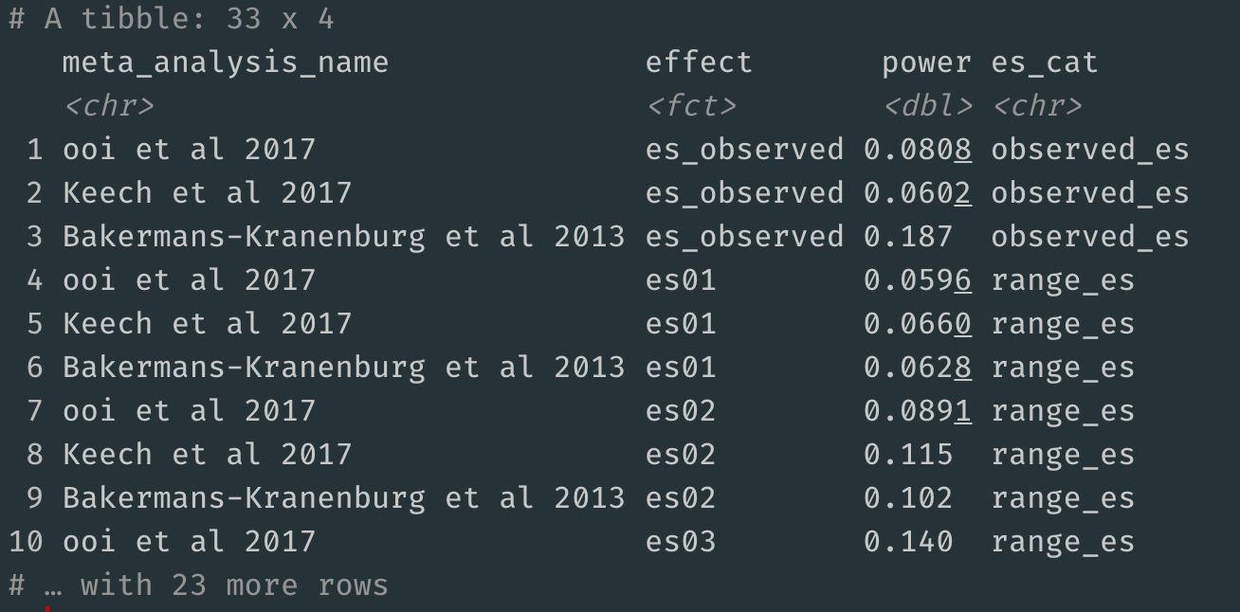
Try out this package for yourself either using the three example datasets or your own data. If you find any bugs or have feature requests, please file an issue on the package's GitHub page.

Equivalence-enhanced forest plots with power tiles for meta-analysis
Fuente: https://www.dsquintana.blog/equivalence-enhanced-forest-plots-with-power-tiles/
Unlike primary research, most meta-analysis articles provide enough information to recreate their results. This information tends to be reported in forest plots, which provide a summary of the extracted effect size from each study, along with some measure of variance, like standard error or a confidence interval.
As well as facilitating the verification of the results, this easily extractable information also provides the opportunity for the reanalysis of data.
Some meta-analyses report a non-significant summary effect size and conclude that there is no effect. However, a non-significant result only means that you failed to reject the null hypothesis, not that there was support for the null hypothesis. However, equivalence tests make it possible to reject of effects as large, or larger, than a smallest effect size of interest. For instance, if you believe that an effect of d = 0.2 or smaller is practically meaningless, then you can perform an equivalence test to reject effects that are as large, or larger, than d = 0.2. If the result of this test is statistically significant, then you could conclude that the effect was statistically equivalent.
Equivalence tests are becoming popular in primary research studies, but I've yet to see one "out in the wild" for a meta-analysis. Fortunately, Daniel Lakens' TOSTER R package provides a function for performing equivalence tests for meta-analytic results.
Let's run a test on a meta-analysis with a summary effect size of 0.07 and a standard error of 0.0918. We'll set our equivalence bounds at 0.2.
library(TOSTER)
TOSTmeta(ES = 0.07,
se = 0.0918,
low_eqbound_d = -0.2,
high_eqbound_d = 0.2)
library(TOSTER)
TOSTmeta(ES = 0.07,
se = 0.0918,
low_eqbound_d = -0.2,
high_eqbound_d = 0.2)
Running this test yields a figure like this.
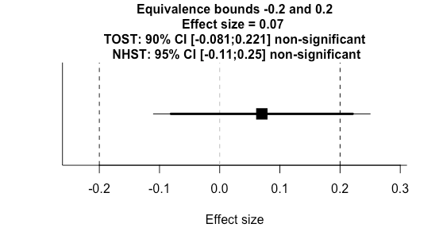
We can see at a glance that the null hypothesis significance test (NHST) was not significant because the 95% confidence interval (thin line) crossed zero. Additionally, we can see the two one sided test (TOST) for equivalence (thick line) was not significant as one of the 90% confidence bounds crossed our equivalence threshold. This is a useful plot, but there's no straightforward way to visualise a series of tests with various equivalence bounds.
There are two reasons you might want to combine a series of tests. First, you might have several meta-analysis results from a single paper you would like to combine into a single figure. Second, you might want to combine results from different papers that address similar research questions.
I'm working on a project that's addressing the second question. I couldn't find a good solution for visualising equivalence tests for a series of summary effect sizes, so I made my own R function, which you can access on my Github repository.
So now we're going to run a function to analyse the data (also available on my Github repository).
leppanen_2017_1_results <- ma_pipe_sei(
"dat_leppanen_2017_1.csv", # Load data
true_effect = 0.09, # Reported effect size
rep_lower = -0.06, # Reported lower bound
rep_upper = 0.24, # Reported upper bound
analysis_title = "Leppanen_2017_1", # Title of analysis
plot = TRUE
)
leppanen_2017_1_et_dat <- leppanen_2017_1_results$et # Extract equivalence test results
leppanen_2017_1_results <- ma_pipe_sei(
"dat_leppanen_2017_1.csv", # Load data
true_effect = 0.09, # Reported effect size
rep_lower = -0.06, # Reported lower bound
rep_upper = 0.24, # Reported upper bound
analysis_title = "Leppanen_2017_1", # Title of analysis
plot = TRUE
)
leppanen_2017_1_et_dat <- leppanen_2017_1_results$et # Extract equivalence test results
The funtion ma_pipe_sei takes the extracted data of a meta-analysis, and has to include two columns: "yi" with effect size data, "lower" with the lower confidence interval bound, and "upper" with the upper confidence interval bound.
ma_pipe_sei
This function calculates the standard error for each study effect based on the upper and lower confidence interval bounds. It performs meta-analysis, outputs the data, creates a sunset plot, performs an equivalence test, and visualises the equivalence test. We can extract these outputs one-by-one into new objects.
leppanen_2017_1_res <- leppanen_2017_1_results$res # Meta-analysis results
leppanen_2017_1_data <- leppanen_2017_1_results$dat # Meta-analysis raw data
leppanen_2017_1_sunset <- leppanen_2017_1_results$sunset # Meta-analysis sunset plot
leppanen_2017_1_et_plot <- leppanen_2017_1_results$et_plot # Extract equivalence test results
leppanen_2017_1_et_dat <- leppanen_2017_1_results$et # Extract equivalence test results
leppanen_2017_1_res <- leppanen_2017_1_results$res # Meta-analysis results
leppanen_2017_1_data <- leppanen_2017_1_results$dat # Meta-analysis raw data
leppanen_2017_1_sunset <- leppanen_2017_1_results$sunset # Meta-analysis sunset plot
leppanen_2017_1_et_plot <- leppanen_2017_1_results$et_plot # Extract equivalence test results
leppanen_2017_1_et_dat <- leppanen_2017_1_results$et # Extract equivalence test results
Now we just repeat this for other meta-analysis datasets (see my Github repository for additional example data and analysis scripts).
Now we can combine the results and create our plot.
com1 <- rbind(leppanen_2017_1_et_dat,
leppanen_2017_2_et_dat,
leppanen_2017_3_et_dat,
leppanen_2017_4_et_dat,
leppanen_2017_5_et_dat,
leppanen_2017_6_et_dat)
com1 <- combine_et(com1)
com1 <- com1 + ggtitle("Summary effect sizes and equivalence bounds") +
theme(plot.title = element_text(hjust = 0.5))
com1 <- rbind(leppanen_2017_1_et_dat,
leppanen_2017_2_et_dat,
leppanen_2017_3_et_dat,
leppanen_2017_4_et_dat,
leppanen_2017_5_et_dat,
leppanen_2017_6_et_dat)
com1 <- combine_et(com1)
com1 <- com1 + ggtitle("Summary effect sizes and equivalence bounds") +
theme(plot.title = element_text(hjust = 0.5))
This uses the combine_et() function, that's also in my script. Here, you just need to input a dataset that contains all the equivalence test results you would like to include. I've also added a title to the figure.
combine_et()
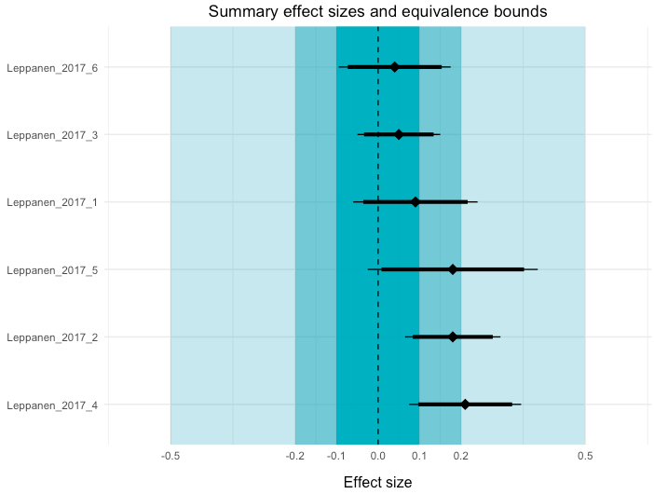
In this plot, I've visualised three equivalence test bounds: 0.1, 0.2, 0.5. You can also see the 95% NHST confidence intervals (thin lines) and the 90% TOST confidence intervals for each meta-analysis. If you would consider effects smaller than 0.2 to be practically unimportant, the first two meta-analyses demonstrate equivalent effects.
The second complementary visualisation that I've created, which I've called power tiles, illustrates the median statistical power of each study that was included in the meta-analysis. A meta-analysis that is comprised of studies with low statistical power is less credible than one that includes studies with high power. To create this function, I've adapted code from the 'metaviz' R package.
One element of this power analysis is that you need enter the "true" effect size for this calculation. As this is difficult in practice, I've included three options: The summary effect size calculated from the meta-analysis, an effect size of 0.33, and an effect size of 0.66. Here's the script you need to run, which will also combine the power tile plot with our equivalence-enhanced forest plot.
power_med <- rbind(leppanen_2017_1_power_median_dat,
leppanen_2017_2_power_median_dat,
leppanen_2017_3_power_median_dat,
leppanen_2017_4_power_median_dat,
leppanen_2017_5_power_median_dat,
leppanen_2017_6_power_median_dat)
power_med_long <- gather(power_med, effect, power, observed:e66, factor_key=TRUE)
tile <- ggplot(data = power_med_long, aes(x = effect, y = reorder(analysis, -ES),)) +
geom_tile(aes(fill = power)) +
coord_equal(ratio = 0.8) +
scale_fill_gradient(name = "Power", low = "#FDF0FF", high = "#E200FD") + theme_tufte(base_family="Helvetica")
tile <- tile + theme(axis.text.y = element_blank(),
axis.ticks.y = element_blank(),
axis.title.y = element_blank())
tile <- tile + ggtitle("Median statistical power") +
xlab("Effect size") +
theme(plot.title = element_text(hjust = 0.5))
tile <- tile + scale_x_discrete(labels=c("observed" = "Observed \n effect", "e33" = "0.33",
"e66" = "0.66"))
tile
# Combine the two plots
com1 + tile
power_med <- rbind(leppanen_2017_1_power_median_dat,
leppanen_2017_2_power_median_dat,
leppanen_2017_3_power_median_dat,
leppanen_2017_4_power_median_dat,
leppanen_2017_5_power_median_dat,
leppanen_2017_6_power_median_dat)
power_med_long <- gather(power_med, effect, power, observed:e66, factor_key=TRUE)
tile <- ggplot(data = power_med_long, aes(x = effect, y = reorder(analysis, -ES),)) +
geom_tile(aes(fill = power)) +
coord_equal(ratio = 0.8) +
scale_fill_gradient(name = "Power", low = "#FDF0FF", high = "#E200FD") + theme_tufte(base_family="Helvetica")
tile <- tile + theme(axis.text.y = element_blank(),
axis.ticks.y = element_blank(),
axis.title.y = element_blank())
tile <- tile + ggtitle("Median statistical power") +
xlab("Effect size") +
theme(plot.title = element_text(hjust = 0.5))
tile <- tile + scale_x_discrete(labels=c("observed" = "Observed \n effect", "e33" = "0.33",
"e66" = "0.66"))
tile
# Combine the two plots
com1 + tile
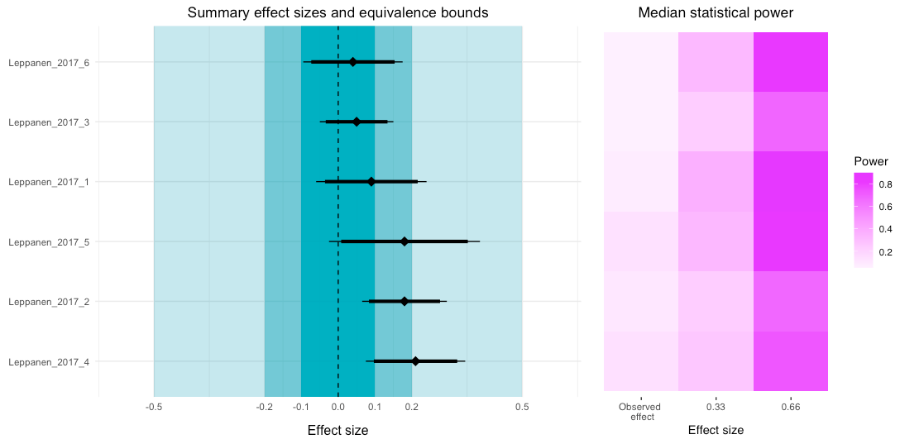
Looking at the power tile plot, we can see that for the observed effects the median power was very low. However, if the true effect size was higher, then the power for each study (or to be more precise, the tests reported in the study) would be sufficient.
The code is a little messy, but I wanted to share an early version to get some feedback. Please let me know if you have any suggestions on how I can improve these visualisations.

Sunset funnel plots for meta-analysis
Fuente: https://www.dsquintana.blog/meta-analysis-power-plot/
Garbage in, garbage out is a common criticism of meta-analysis. While I'm generally a fan of meta-analysis, I think this is a very fair critique.
One approach to determine the evidential value of studies included in a meta-analysis is to determine the statistical power of the reported tests that were used. Tests with low statistical power have a low probability of finding a statistically significant effect, if there's a true effect to be found. This also means that tests with low statistical power are less likely to replicate. Consequently, a meta-analysis that contains studies with low power is likely to comprise results that won't replicate and a summary effect size estimate that is inflated.
You can calculate statistical power one-by-one for each effect size, but this is time consuming. However, it's possible to calculate statistical power using the information that has already been extracted for a meta-analysis, namely, a set of effect sizes and their variances.
To demonstrate this, I'm going to use the sunset_viz function from the metaviz R package. This function creates a sunset funnel plot, which is funnel plot variant that visualises the statistial power of each test included in the meta-analysis.
sunset_viz
metaviz
This function is relatively straightforward, however, you will need to specify the "true" population effect size. There are a few approaches you can take to specify this.
- Use the summary effect size from the meta-analysis
This is the most straightforward approach, and the default in this function, but this effect size is likely to be inflated due to publication bias.
2. Use a publication-bias adjusted effect size
There a various tools, like p-uniform, that can be used to calculate a publication bias-adjusted effect size. However, these tool has some limitations. Namely, this is should only be used for meta-analyses with low heterogeneity, and it can't be used for multilevel meta-analysis (e.g., meta-analyses that account for multiple effect sizes from individual studies).
3. Determine the smallest effect size of interest
The smallest effect size if interest (SESOI) is the smallest effect size you care about for the research question at hand. For example, if for your research question an effect size lower than d = 0.1 is essentially meaningless or has no practical value, then d = 0.1 is your SESOI. If your test is sensitive enough to to detect the smallest effect size of interest, then it's able to detect larger effects as well.
For a quick demonstration, consider this plot below, which was created by the 'jpower' module in JAMOVI. Let's say our SESOI is 0.1 and we have 250 participants for a paired samples t-test. This design can detect effect sizes of 0.2 with a probability of at least 0.88 (i.e., 88% power) when α=0.05 (two-tailed). If the "true" effect size is higher than 0.2, then the probability of detecting these effect sizes are higher than 88%.
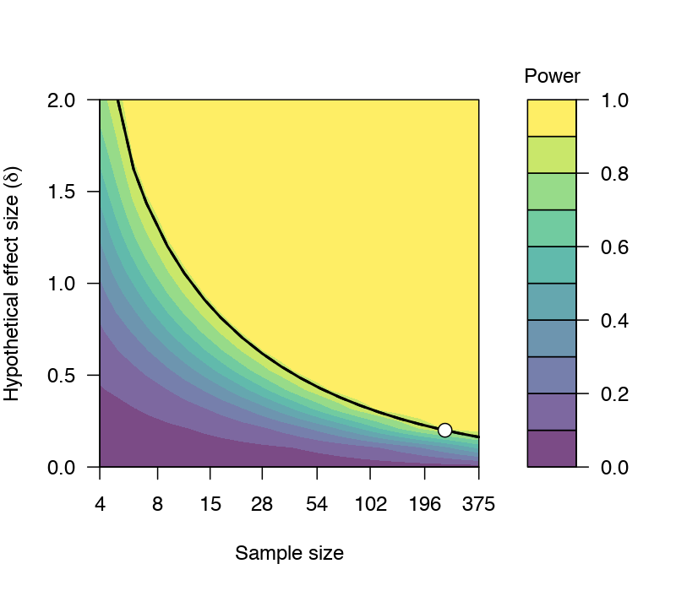
Now, to demonstrate this tool, let's use an example correlational dataset that I've used in previous demonstrations to perform a conventional meta-analysis.
library(metafor) #Load metafor
library(metaviz) #Load metaviz
library(puniform) #Load puniform
dat <- get(data(dat.molloy2014)) # Extract data
dat <- escalc(measure="ZCOR",
ri=ri, ni=ni,
data=dat) #Calculate effect sizes
res <- rma.uni(yi, vi, data=dat)
forest_plot <- forest(res)
forest_plot
library(metafor) #Load metafor
library(metaviz) #Load metaviz
library(puniform) #Load puniform
dat <- get(data(dat.molloy2014)) # Extract data
dat <- escalc(measure="ZCOR",
ri=ri, ni=ni,
data=dat) #Calculate effect sizes
res <- rma.uni(yi, vi, data=dat)
forest_plot <- forest(res)
forest_plot
Here are the results of this meta-analysis.
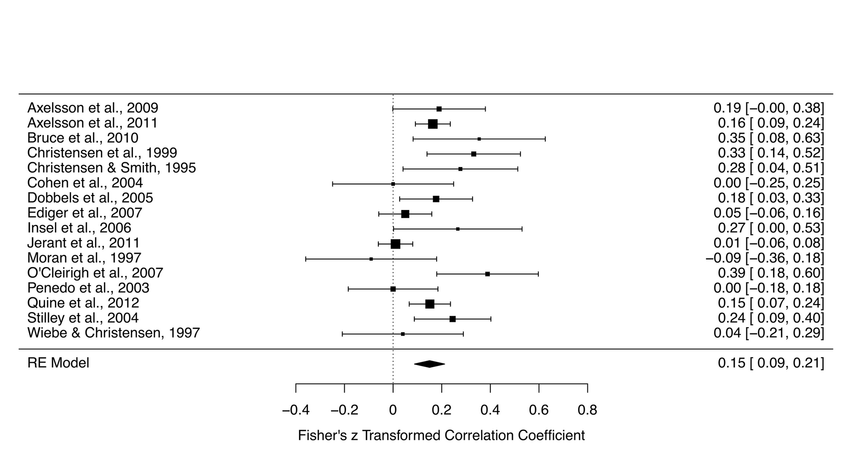
Let's also make a funnel plot, which illustrates the potential for small-study bias by plotting each effect size against its standard error, centred on the estimated summary effect size.
funnel_plot <- funnel(res)
funnel_plot
funnel_plot <- funnel(res)
funnel_plot
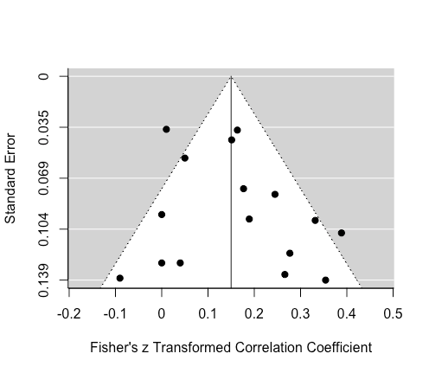
We can improve this plot by adding 'significance' contours and centring the funnel on zero.
funnel_contour <- funnel(res, level=c(90, 95, 99),
shade=c("white", "orange", "red"),
refline=0, legend="topleft")
funnel_contour
funnel_contour <- funnel(res, level=c(90, 95, 99),
shade=c("white", "orange", "red"),
refline=0, legend="topleft")
funnel_contour
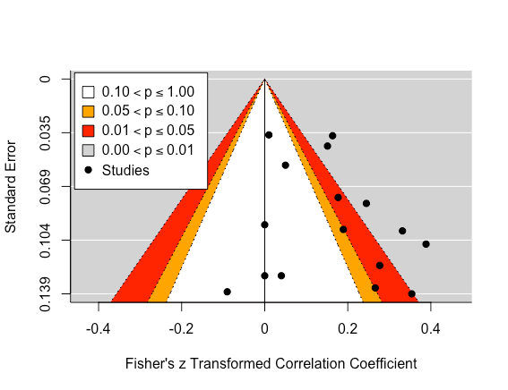
This plot show us that a few studies are lying in the 'significance' contours. While eyeballing this plot doesn't elicit too much concern for publication bias, this would still be a subjective conclusion.
To get a more objective understanding of how much publication bias is influencing the summary effect size estimate, we can adjust for publication bias using the puniform package.
puniform
puni_star(yi = dat$yi, vi = dat$vi,
side = "right")
puni_star(yi = dat$yi, vi = dat$vi,
side = "right")
This analysis suggests that the publication bias adjusted estimate is 0.11, which is a little lower than the original estimate of 0.15.
So now we have two (out of our three) options for determining the "true" effect size. For the third option, let's assume that the smallest correlation coefficient we care about is 0.05.
We're now ready to calculate power and create a sunset plot. Let's begin by using the original effect size estimate. By default, this function uses the original effect size estimate so you don't need to specify it.
viz_sunset(res,
contours = TRUE,
power_contours = "continuous")
viz_sunset(res,
contours = TRUE,
power_contours = "continuous")
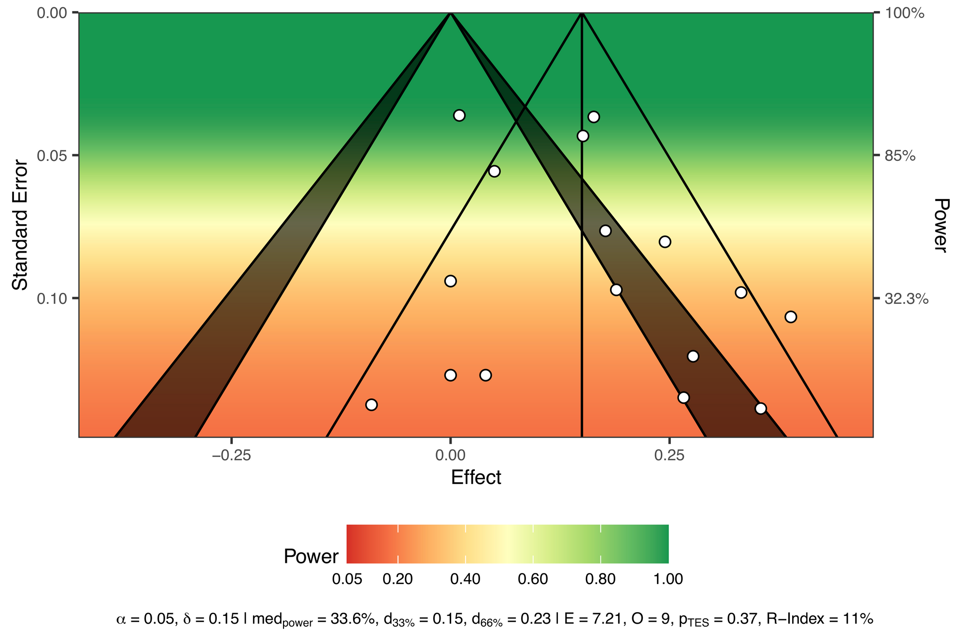
Let's walk through this plot.
Power is visualized by colour, with red used for "danger", as in, "these tests are very underpowered". The description at the bottom also displays the following:
- The alpha (0.05)
- The true effect size (0.15)
- The median power of all the tests (33.6%)
- The true effect size needed for achieving 33% (0.15) and 66% (0.23) of median power
- Results from a test of excess significance (i.e., given the data we would expect 7.21 statistically significant studies and we observed 9, yielding a p-value of 0.37)
- An R-Index measure of 11%, suggesting that these studies have a low probablility of replicating
To use our minimally interesting effect for the true effect size, we just need to tweak the code a little.
viz_sunset(res,
contours = TRUE,
true_effect = 0.05,
power_contours = "continuous")
viz_sunset(res,
contours = TRUE,
true_effect = 0.05,
power_contours = "continuous")
All tests reported from these studies are underpowered to detect this minimally interesting effect.
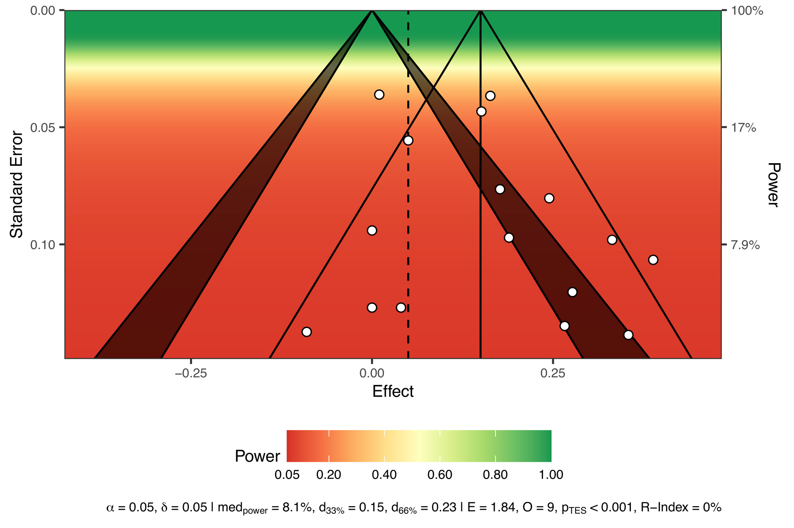
Finally, if you are interesting in extracting the exact power values, I have put together a small custom function.
s_power <- function(se, true_effect, sig_level) {
(1 - stats::pnorm(stats::qnorm(1 - sig_level/2) *
se, abs(true_effect), se)) +
stats::pnorm(stats::qnorm(sig_level/2) *
se, abs(true_effect), se)
}
s_power <- function(se, true_effect, sig_level) {
(1 - stats::pnorm(stats::qnorm(1 - sig_level/2) *
se, abs(true_effect), se)) +
stats::pnorm(stats::qnorm(sig_level/2) *
se, abs(true_effect), se)
}
Let's use this function to add power calculations to each study using a true effect size of 0.15. We also need to specify the standard error for each effect, and significance level. Here, we're using data from the funnel plot we made earlier to extract the standard error information.
dat$power <- s_power(se = funnel_plot$y,
true_effect = 0.15,
sig_level = 0.05)
dat$power <- s_power(se = funnel_plot$y,
true_effect = 0.15,
sig_level = 0.05)
Now we have the precise power estimates for each effect size at the end of our dataset.
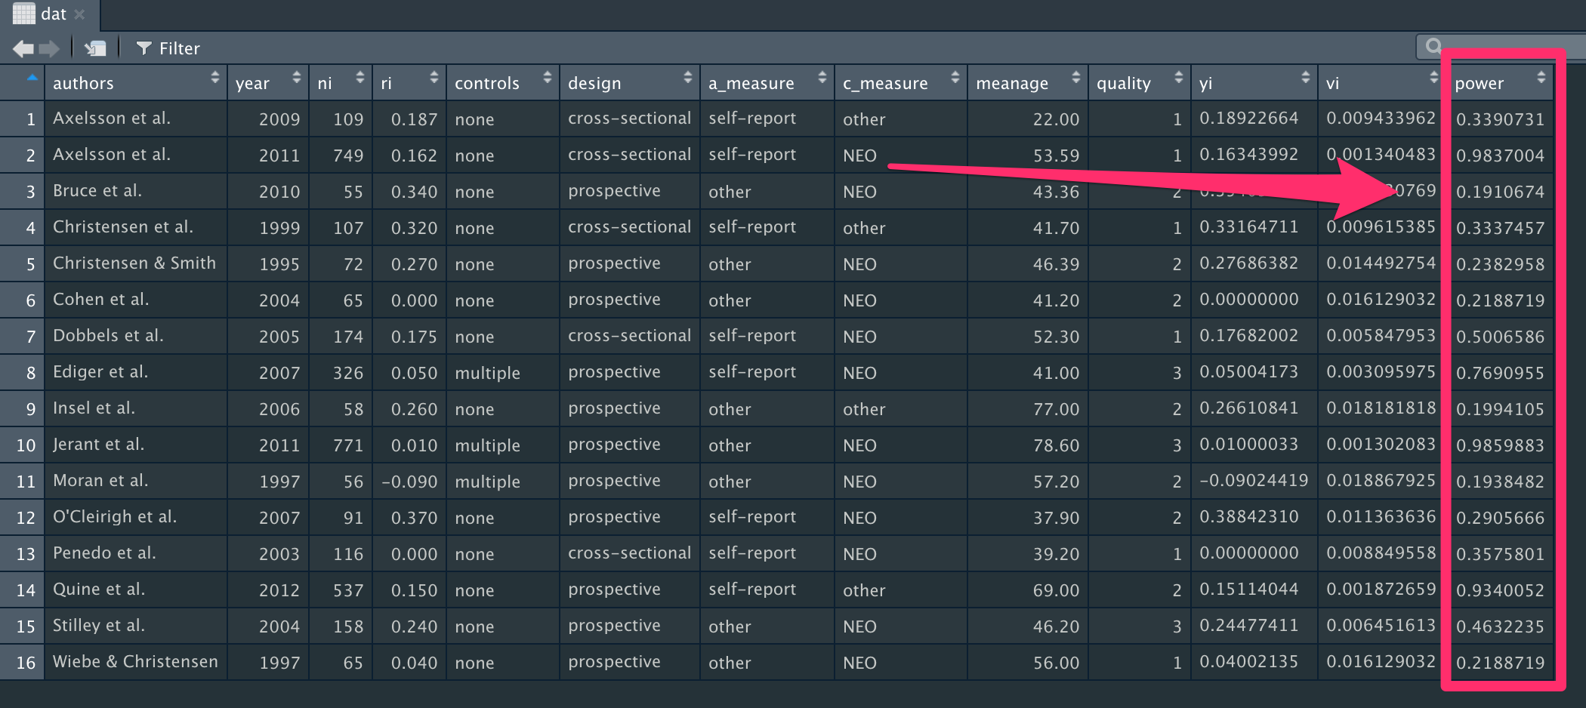
Here's the full script, if you'd like to run this all in one go.
library(metafor) #Load metafor
library(metaviz) #Load metaviz
library(puniform) #Load puniform
dat <- get(data(dat.molloy2014)) # Extract data
dat <- escalc(measure="ZCOR",
ri=ri, ni=ni,
data=dat) #Calculate effect sizes
res <- rma.uni(yi, vi, data=dat)
forest_plot <- forest(res)
forest_plot
funnel_plot <- funnel(res)
funnel_plot
funnel_contour <- funnel(res, level=c(90, 95, 99),
shade=c("white", "orange", "red"),
refline=0, legend="topleft")
funnel_contour
puni_star(yi = dat$yi, vi = dat$vi,
side = "right")
viz_sunset(res,
contours = TRUE,
power_contours = "continuous")
viz_sunset(res,
contours = TRUE,
true_effect = 0.05,
power_contours = "continuous")
s_power <- function(se, true_effect, sig_level) {
(1 - stats::pnorm(stats::qnorm(1 - sig_level/2) *
se, abs(true_effect), se)) +
stats::pnorm(stats::qnorm(sig_level/2) *
se, abs(true_effect), se)
}
dat$power <- s_power(se = funnel_plot$y,
true_effect = 0.15,
sig_level = 0.05)
library(metafor) #Load metafor
library(metaviz) #Load metaviz
library(puniform) #Load puniform
dat <- get(data(dat.molloy2014)) # Extract data
dat <- escalc(measure="ZCOR",
ri=ri, ni=ni,
data=dat) #Calculate effect sizes
res <- rma.uni(yi, vi, data=dat)
forest_plot <- forest(res)
forest_plot
funnel_plot <- funnel(res)
funnel_plot
funnel_contour <- funnel(res, level=c(90, 95, 99),
shade=c("white", "orange", "red"),
refline=0, legend="topleft")
funnel_contour
puni_star(yi = dat$yi, vi = dat$vi,
side = "right")
viz_sunset(res,
contours = TRUE,
power_contours = "continuous")
viz_sunset(res,
contours = TRUE,
true_effect = 0.05,
power_contours = "continuous")
s_power <- function(se, true_effect, sig_level) {
(1 - stats::pnorm(stats::qnorm(1 - sig_level/2) *
se, abs(true_effect), se)) +
stats::pnorm(stats::qnorm(sig_level/2) *
se, abs(true_effect), se)
}
dat$power <- s_power(se = funnel_plot$y,
true_effect = 0.15,
sig_level = 0.05)

Oh my GOSH: Calculating all possible meta-analysis study combinations
Fuente: https://www.dsquintana.blog/combinatorial-meta-analysis/
There are several analytical decisions that need to made when performing a meta-analysis. These decisions are not trivial, as they can influence meta-analysis outcomes and conclusions.
One of these decisions is deciding which studies to include in the meta-analysis. A single study, or group of studies, can have a disproportionate influence on the summary effect size.
Let's fire up up R and have a closer look. Here, I'm going to load up the metafor package and use one its built-in meta-analysis datasets. This meta-analysis dataset from Molloy and colleagues explores the relationship between conscientiousness and medication adherence.
metafor
Here's a basic meta-analysis, which extracts the data, calculates an effect size measure and effect size variance, and creates a forest plot for visualisation.
library(metafor) #Load metafor
dat <- get(data(dat.molloy2014)) # Extract data
dat <- escalc(measure="ZCOR",
ri=ri, ni=ni,
data=dat) #Calculate effect sizes
res <- rma.uni(yi, vi, data=dat)
forest_plot <- forest(res)
library(metafor) #Load metafor
dat <- get(data(dat.molloy2014)) # Extract data
dat <- escalc(measure="ZCOR",
ri=ri, ni=ni,
data=dat) #Calculate effect sizes
res <- rma.uni(yi, vi, data=dat)
forest_plot <- forest(res)
Let's look at the forest plot that was generated from this script. The summary effect size was 0.15, and this was statistically significant, suggesting a modest relationship between conscientiousness and medication adherence.
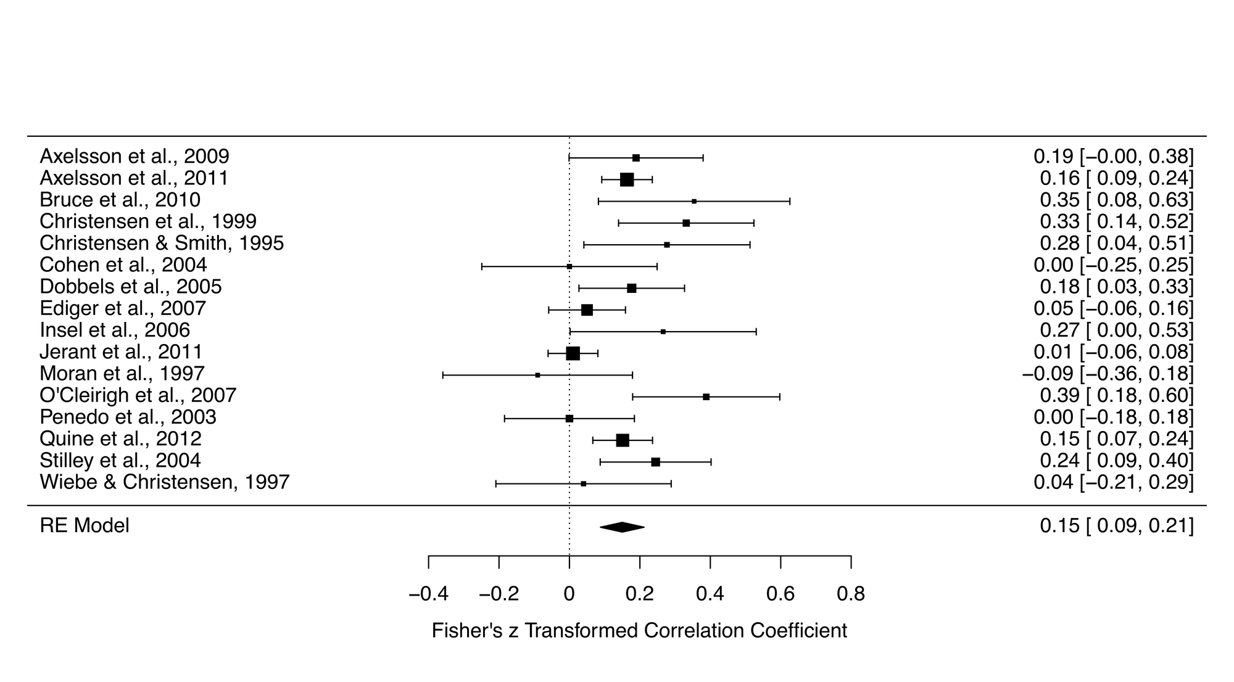
To demonstrate the robustness of the result, it's good practice to perform a leave-one-out analysis. Like the name suggests, this analysis performs a series of meta-analyses leaving one of the studies out. So if you had 15 studies in your meta-analysis, you would have 15 meta-analyses.
Here is the script to run this:
l_one <- leave1out(res)
l_one <- leave1out(res)
And here are the results:
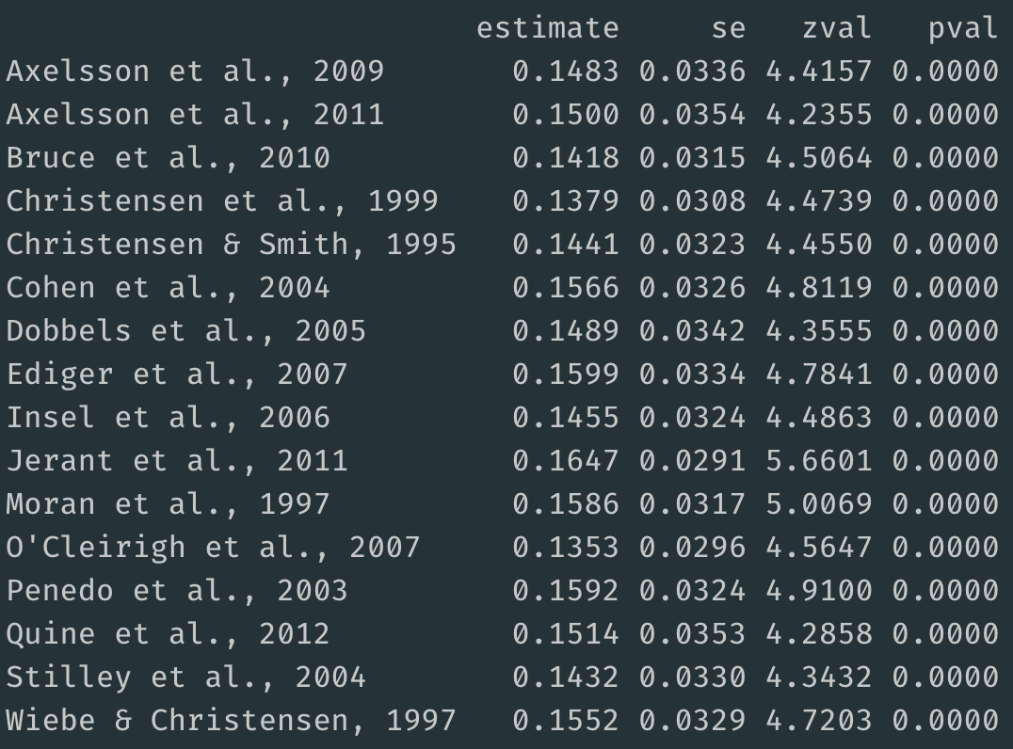
The summary effect sizes for meta-analyses that removed a single study ranged from 0.14 to 0.16. Thus, removing a single study did not have much influence on the primary summary effect size, which as 0.15.
This analysis is quite informative, but perhaps there's a distinct subgroup of studies influencing the result, rather than a single study.
So let's what's called a combinatorial meta-analysis, which performs a series of meta-analyses based on all possible combinations of studies.
The number of analyses to be conducted can be calculated using the formula 2^k - 1, with k representing the number of studies. So for a meta-analysis with 16 studies, you will perform 65535 meta-analyses, that is 2^16 - 1.
2^k - 1
2^16 - 1
To visualise this enormous number of summary effect size estimates, we'll put together a Graphical Display of Study Heterogeneity (GOSH) plot, using the following script, but before running the script, I should warn you that this could take some time to create 65535 models (it took about 10 minutes on my 2015 MacBook Pro).
gp <- gosh(res)
g_plot <- plot(gp, breaks = 100)
g_plot
gp <- gosh(res)
g_plot <- plot(gp, breaks = 100)
g_plot
Here's a visualisation of the summary effects of 65535 models (horizontal axis), plotted against the model's heterogeneity (vertical axis).
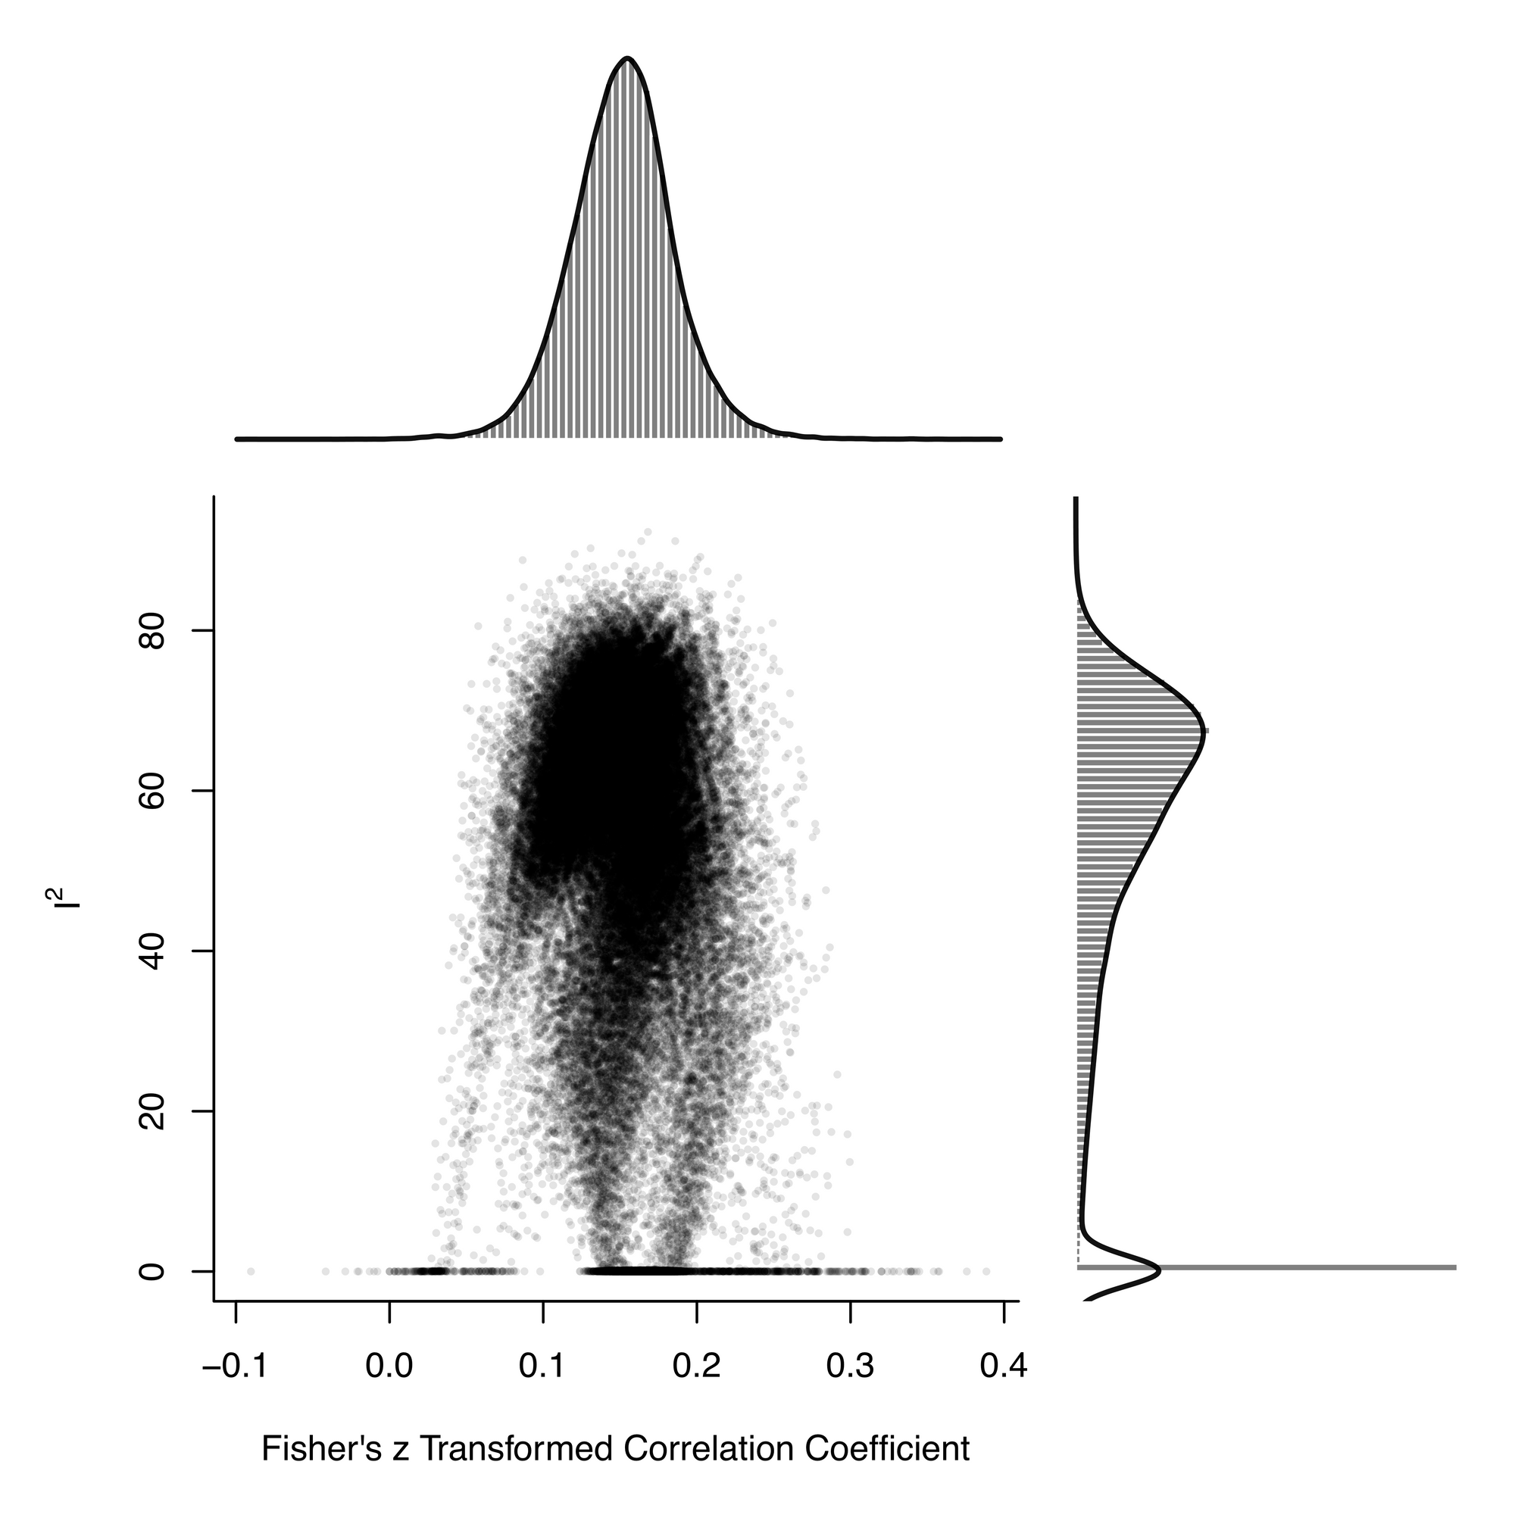
By extracting the list of effect sizes, it's straightforward to calculate the mean effect size, which is 0.15.
mgosh <- gp$res
mean_est <- mean(mgosh$estimate, na.rm = TRUE)
mgosh <- gp$res
mean_est <- mean(mgosh$estimate, na.rm = TRUE)
The effect sizes range from about 0.05 to 0.25, demonstrating how the choice of included studies influences the summary effect size estimate.
Now let's see what happens when we add in some artificial outliers, using this script:
dat_mo <- get(data(dat.molloy2014))
dat_mo <- escalc(measure="ZCOR",
ri=ri, ni=ni, data=dat_m)
dat_mo[12,11] = 0.7
dat_mo[15,11] = 0.6
res_mo <- rma.uni(yi, vi, data=dat_mo)
forest(res_mo)
dat_mo <- get(data(dat.molloy2014))
dat_mo <- escalc(measure="ZCOR",
ri=ri, ni=ni, data=dat_m)
dat_mo[12,11] = 0.7
dat_mo[15,11] = 0.6
res_mo <- rma.uni(yi, vi, data=dat_mo)
forest(res_mo)
You can see the introduced outliers in the forest plot (studies 12 and 15)
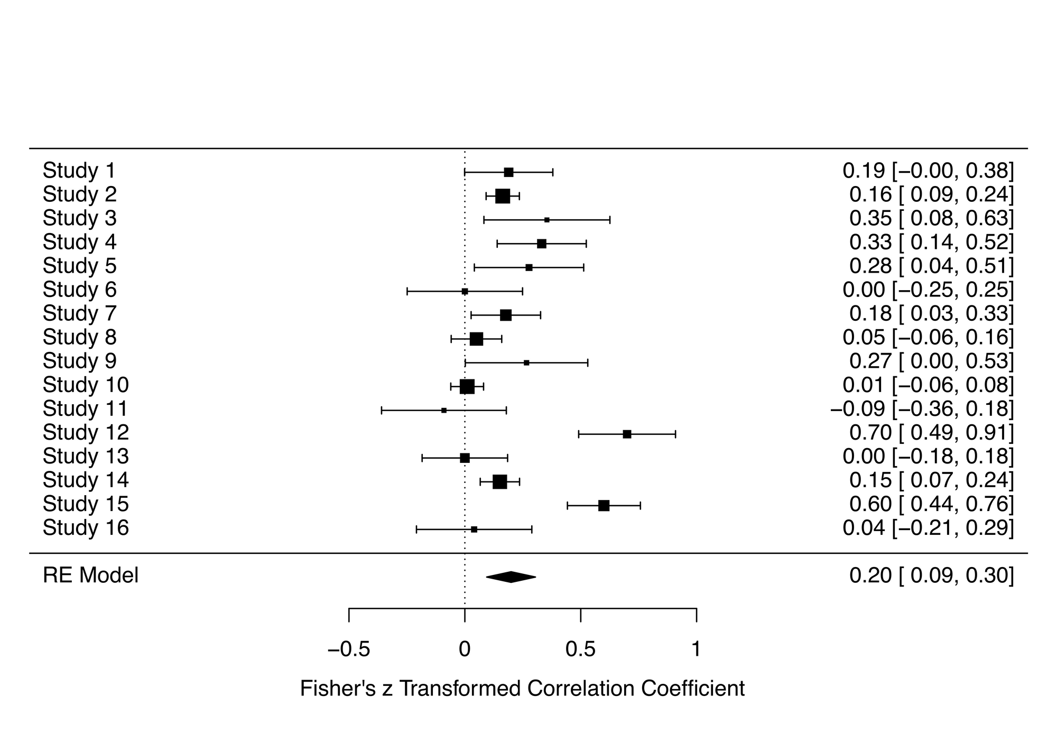
Now let's run the combinatorial meta-analysis and create a GOSH plot:
gp_mo <- gosh(res_mo)
plot(gp_mo, breaks = 100)
gp_mo <- gosh(res_mo)
plot(gp_mo, breaks = 100)
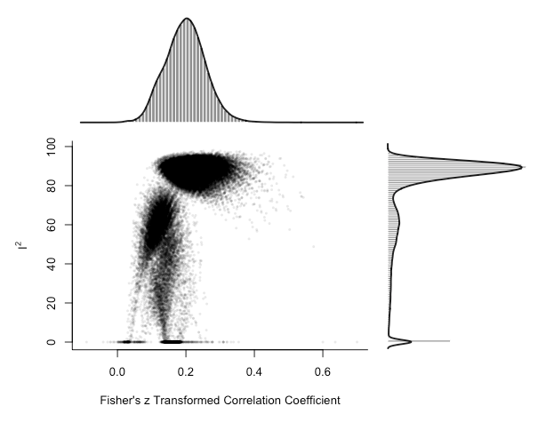
There is a clear cluster of large effect sizes with high heterogeneity in the top right of the plot. We can specifically highlight the meta-analysis models that included the potential outlier studies:
plot(gp_mo, out=12, breaks = 100)
plot(gp_mo, out=12, breaks = 100)
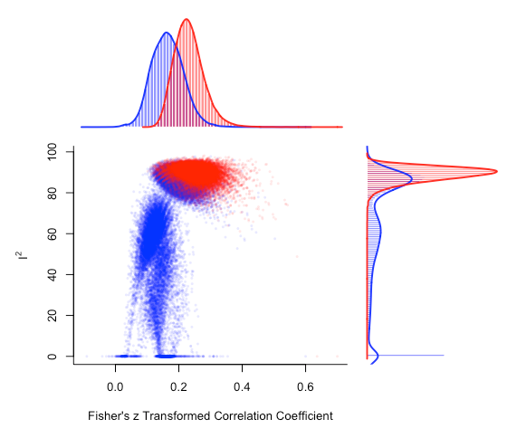
There's a noticeable shift in the distribution of meta-analysis model summary effect size estimates that include study 12.
Ultimately, combinatorial meta-analysis paired with GOSH plots demonstrate how your analysis choices influence your meta-analysis outcomes and conclusions.

